Contents

RESOURCES / TOOLS 6

Getting Course Code 6

Drawing Diagrams 6

BASE CONCEPTS 6

Abstraction and Encapsulation 6

Inheritance 6

Polymorphism 6

Refactoring 6

Hot Loop 7

Big O Notation 7

Comparing Notations 8

Performance Analysis 8

Inline 9

Implicit Dependencies 9

Data Locality 10

VERSION CONTROL 10

Types 10

GIT / SourceTree 10

C++ 11

Operands 11

Loops and Iterators 11

for 11

for_each 11

while 11

Types 11

Auto 11

Using / Typedef 11

Enumerations 11

Data Structures 12

Hash Table 12

Map 12

Set 13

Structs 13

Classes 13

Functions 18

Return Types 18

Side Effects 18

Preprocessor Directives 18

Namespaces 18

Pointers 18

Arrays 18

Initialization 19

Arithmetic 19

Const 20

Access 20

Void 20

Null 20

Functions 21

Memory 21

Libraries 22

iostream 22

string 22

Magic Numbers 22

Conditionals 22

Switch 22

Constants 22

constexpr 22

const 23

Booleans 23

Dependency Mapping 23

UNREAL 23

AI 23

Algorithms 23

PathFinding 23

Landscapes 24

Materials 25

Changing Poly Count 27

Scale 27

Selecting a Template 28

Blueprints or C++ 28

Components 28

Types 28

Game Mode 29

Player Controllers 30

User Input 30

Show Mouse Cursor For UI 30

Modes 31

Game Only 31

UI Only 31

Game and UI 31

Blueprint 31

Organization 32

Output to More than One node / Sequence Node 32

User Interface 32

3rd Person Camera System 34

TimeLine Node 35

New Game Modes 36

Sockets 37

Setup 37

Input 38

Bindings 38

PawnInputComponent 38

Fly By Wire 38

Collisions 38

Primitves / Simple 38

Filtering 39

Physics 42

Auto Weld 42

Physics Materials 42

Friction 43

Build System 43

Updating to a new version of unreal 43

Visual Studio 43

Basics 44

Includes 44

Accessing Code in Unreal 44

Errors / Debugging 45

Unreal C++ 45

Finding Example Code 45

Resetting the Project 45

Removing a C++ Class 45

Constructors and Begin Plays 45

Enums 45

Functions 46

Classes 46

Class system / Viewer 48

Trigger Volumes 48

Player 49

Pawn 49

AI 49

Actor 50

Spawning 50

2D to 3D projection of a point 50

Transforms 51

Runtime Feedback 52

Events / Ticking 52

Variables / Properties / Attributes 52

Polling and Events 53

TArray 53

Pointer Protection 53

Vectors 53

Audio 53

BluePrints 54

Directory Structure 60

Derived Files 60

Debugging 60

Visualization 60

Compiling 60

Checking Ticks 60

Visual Studio Debugger 61

Refactor Issues 62

Unreal Issues 62

VISUAL STUDIO 62

Projects and Solutions 62

Tools 63

Extraction 63

Debugging 63

BreakPoints 63

Watch 64

Management 64

Task List 64

Shortcuts 64

Troubleshooting 64

GAME DEVELOPMENT 64

Game Design Document 64

TO DOCUMENT 65

Getting Projectile Landing Location 66

Grabbing System 67

1. Modifying Default Pawn Actor 67

2. Inherit Game Mode Blueprint 67

3. Create Grabber logic 67

4. Setup Collisions 69

CODE REFERENCE 70

Hashing 70

Find first repeating character 70

# RESOURCES / TOOLS

* Provide Expected Behavior, Then Observed Behavior, Steps to Reproduce, What you Tried, Other Info like Version of VS Studio, Include code in message using the curly braces or Gist (gist.gethub.com) and link to it.
* Community.gamedev.tv
* <http://www.learncpp.com/>
* <http://www.cplusplus.com>
* htttp://wolframaplpha.com
* “Level Up” by Scott Rodgers
* TreeSize – scan directories for size usage

## Getting Course Code

Click the Lecture Project Changes  
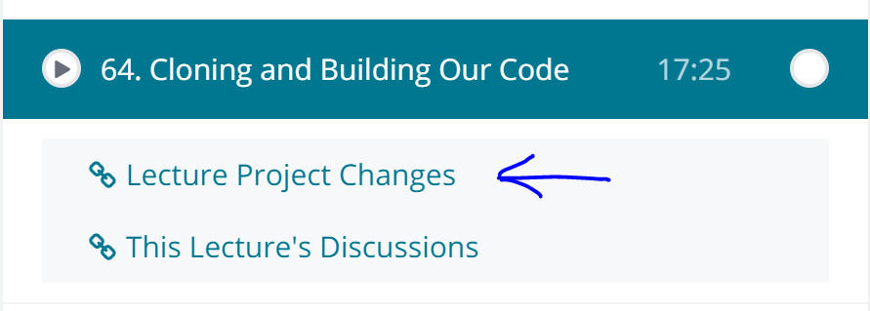

## Drawing Diagrams

<https://www.draw.io/>

## Game Programming

http://gameprogrammingpatterns.com/observer.html

# BASE CONCEPTS

## Abstraction and Encapsulation

Abstraction is a technique for managing complexity, by considering things at a higher level. Thinking about how can simplify code into functions. Encapsulation is making sure abstraction is adhered to – writing the function.

## Inheritance

* “is a” relationship

## Polymorphism

Polymorphism is declaring a uniform interface that isn't type aware, leaving implementation details to concrete types that implement the interface, could also say the ability of objects of one type to have one and the same interface, but different implementation of this interface. The idea is that when I ask for something to be done, I don't care how it is achieved as long as the end result is appropriate. As long as the service is provided correctly, I don't care about the implementation.

* Related to abstraction and encapsulation - Good abstractions make polymorphism easier to achieve, and good encapsulation helps to prevent details "leaking".

## Refactoring

Renaming and restructuring code.

## Hot Loop

Code that is called often

## Big O Notation

Describes the performance or complexity of an algorithm. Describes time or space used. Always assumes worst case scenario. Common Big O notations:

* O(1) – always executes same time or space regardless size input data set.
* O(N) – linear and in direct proportion to size input data set. Example Loops.
* O(N2) - performance is directly proportional to the square of the size of the input data set. This is common with algorithms that involve nested iterations over the data set. Deeper nested iterations will result in O(N3), O(N4) etc.
* O(2N) - denotes an algorithm whose growth doubles with each addition to the input data set. The growth curve of an O(2N) function is exponential - starting off very shallow, then rising meteorically. An example of an O(2N) function is the recursive calculation of Fibonacci numbers.
* O(log N) – This is log base 2, consider a binary search (pick middle element data set, compare to target, target above then halve the upper data set and compare, but if target lower then halve lower half. Repeat until find), This type of algorithm is described as O(log N). The iterative halving of data sets described in the binary search example produces a growth curve that peaks at the beginning and slowly flattens out as the size of the data sets increase e.g. an input data set containing 10 items takes one second to complete, a data set containing 100 items takes two seconds, and a data set containing 1000 items will take three seconds. Doubling the size of the input data set has little effect on its growth as after a single iteration of the algorithm the data set will be halved and therefore on a par with an input data set half the size. This makes algorithms like binary search extremely efficient when dealing with large data sets.

### Comparing Notations

* Can use wolframalpha.com for example, cmpare n log n, n2, and n.  
  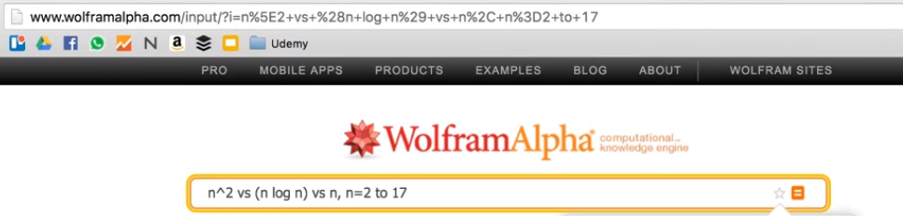  
  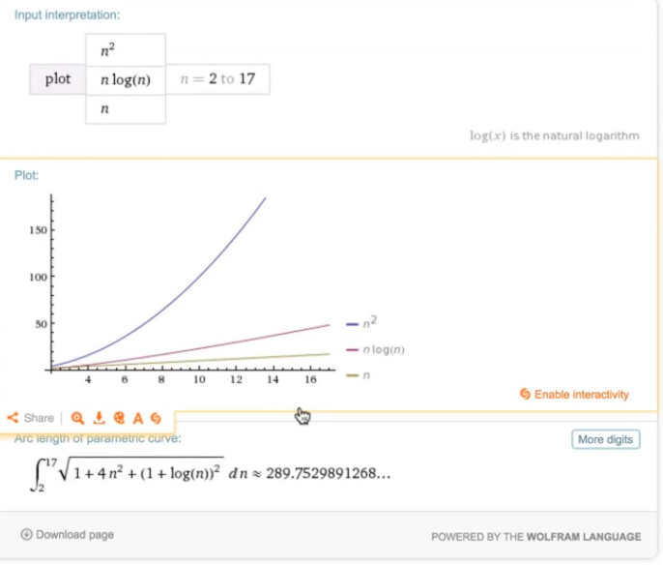

### Performance Analysis

Example: consider finding the first repeating letter in a string. Possible solutions:

1. Could use a nested for loop, i.e. for every character (loop 1), check if it repeats, loop 2 – O(N2)
2. Using a sorting algorithm – O(n log n)
   1. 1) Copy the given array to an auxiliary array temp[].
   2. 2) Sort the temp array using a O(nLogn) time sorting algorithm.
   3. 3) Scan the input array from left to right. For every element, count its occurrences in temp[] using binary search. As soon as we find a character that occurs more than once, we return the character.
3. Use hashing O(n)
   1. Create an empty hash.
   2. Scan each character of input string and insert values to each keys in the hash.
   3. When any character appears more than once, hash key value is increment by 1, and return the character.

## Inline

Putting code all on same line, for example a simple function, if or for:  


## Implicit Dependencies

* Avoid!
* Means its not clear one thing depends on another
* Example: the order of checks in a validity function (see image example below). Each function should be self-contained. In IsIsogram() you should make it case independent for instance. Another check does case. An implicit dependency would be putting the isLowerCase() check first, and then assuming isIsogram() always gets a lowercase word.

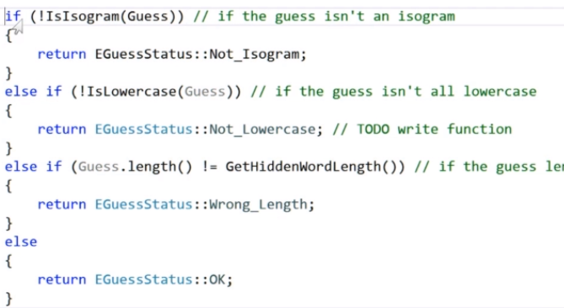

## Data Locality

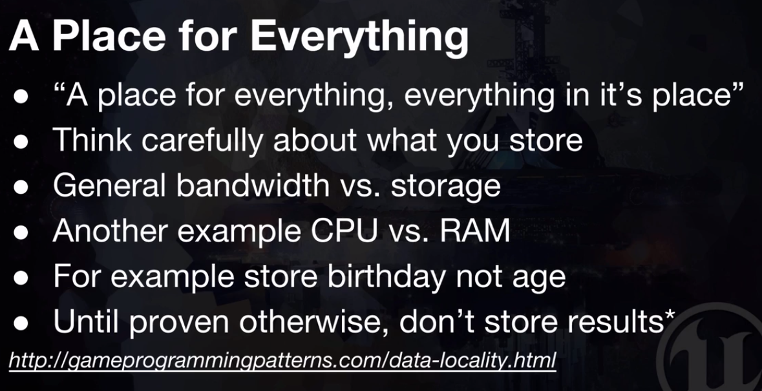

# VERSION CONTROL

## Types

* Git
* Mercurial
* Perforce
* Subversion / TortoiseSVN
* Alienbrain (for visuals, lets you compare images but costs 10,000)
* SourceTree
  + Visual front end for Git and Mercurial

### GIT / SourceTree

#### Ignore Files

* Use .gitignore – exists in root project folder.
* Can create easily in sourceTree by right clicking in unstaged area on a file, and select ignore, gives the option to ignore the file only, or the parent folder. This creates a .gitignore in root project folder. You can now edit this in notepad. Tip: It will put in ProjectName/folder_ignoring. Can put */ignore folder/ to make more generic.

#### Clone

* In source tree click clone and provide the git repository link – can get from git online
* Will download a copy of the project – takes all the versions

#### Explorer

* Lets you look at the folder structure and files for the version of the code.

#### Troubleshooting

* Added a file to .gitignore, but not ignoring.
  + Probably added to .gitignore after file already added. It won’t stop tracking once added, must right click and remove or run git rm *.filetype -f from directory its in.

# C++

## Operands

* << adds right hand code to left hand code
* Ternary operator (Evaluation) ? (Do this if Evaluation is true) : (Do this if evaluation is false)

## Loops and Iterators

### for

when you know at compile time how many times will iterate

* for (initialization; condition; increase)
* for (int count = 1; count<=limit; count++) { statements }

### for_each

Example: for(int x : array) where array is int array[] = {10,20,30,12};

* colon : means in
* for_each is a ranged loop

while  
not sure how long will loop

* while (condition) {statements}
* or do { statements } while (condition); - use when want to run at least once

## Types

* String – in iostream

### Auto

Complier figures out type. Example:   
  
figures out Letter is a char

### Using / Typedef

* For type alias.
* Allows a name to refer to a previously defined type. For example using FText = std::string. FText is a string now

### Enumerations

An enumeration is a distinct type whose value is restricted to a range of values (see below for details), which may include several explicitly named constants ("enumerators"). The values of the constants are values of an integral type known as the underlying type of the enumeration.

#### Examples:

* enum Color { red, green, blue }; then red = 0, green = 1, blue = 2
* enum Foo { a, b, c = 10, d, e = 1, f, g = f + c };

//a = 0, b = 1, c = 10, d = 11, e = 1, f = 2, g = 12

* enum color { red, yellow, green = 20, blue };

color col = red;

int n = blue; // n == 21

* enum { a, b, c = 0, d = a + 2 }; // defines a = 0, b = 1, c = 0, d = 2

#### Accessing

Use ::, so given enum Color {red, green}; Color::red

#### Scope

If make global scope like below, will have issues, for example consider:

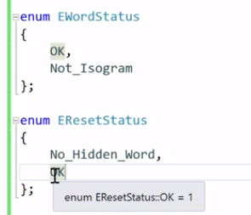

This won’t compile, OK redefined.

#### Class

Put enum class which adds scope to values in enum. Above if added class, then would compile

## Data Structures

### Hash Table

Stores key value pairs. Uses keys to look up entries. Usually done as an array with pointers to linked lists.

### Map

* Map is a associative container that is used to store key-value pair of elements with unique keys.
* It always keeps the inserted pairs in sorted order based on the key.
* Internally it maintains a red-black tree (more refined binary search tree) to store keys. Therefore when searching key inside the map takes only log(n) complexity.
* We cannot modify the key of any inserted pair in map.
* We can modify the value associated with a key in any inserted pair in map.

#### Examples

* Example: std::map<std::string, int > mapOfDepEmpCount;
* Can use [] to access elements, ie mapOfDepEmpCount[i]
* Can check if a key is in the map by doing mapOfDepEmpCount[key] which will return 0 or 1.   
  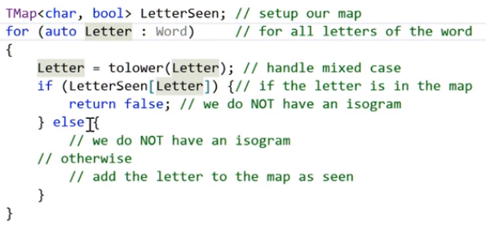

### Set

Example : std::set<std::string> setOfDepartments;

* Set is an associative container which we need to store unique elements.
* It always keeps the elements in sorted order.
* Internally it maintains a balanced binary search tree of elements. Therefore when we search an element inside the set then it takes only log(n) complexity to search it.
* Each element inside the set is const, cannot be modified
* **Difference from Map, can’t associate a value to a key.**

### Structs

* Members default to public if not specified. Below x is public.   
  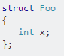
* Struct is no different from a class technically other than members defaulting to public. Struct is class.
* When deriving, members of derived class remain public.

#### POD

Plain Old Data Structs

* Essentially it is a struct that would compile in C, and basically just using built in types.
* Can check by calling std::is_pod

### Classes

* Members default to private unless specify.
* When deriving, members are private even if in base class member is public.
* Class <name> {  
  public:  
  private:  
  };
* Remember variables are private in pure OOO

#### Forward Declaration

Recall you don’t have to include a header, can do class ClassName to let it know it will be there. Also recall that only works in a header file. When you are calling methods it needs the header file. So can’t forward declare in cpp file.

#### Inheritance

* Use Super to access parent method, i.e. if parent has a BeginPlay(), then do Super::BeginPlay()
* To override parent class method, add override to function declaration in header  
  

##### Friendship

use the word ‘friend’, allows a non-member function to access private and protected members of a class. Also allows another class to access the class’s private and protected members.

* Non transitive, The friend of a friend is not considered a friend unless explicitly specified.
* Also never corresponded. Example from below:, Rectangle is considered a friend class by Square, but Square is not considered a friend by Rectangle.
* Declaring a function as a friend: (notice how the function is accessing the private members of class rectangle)  
  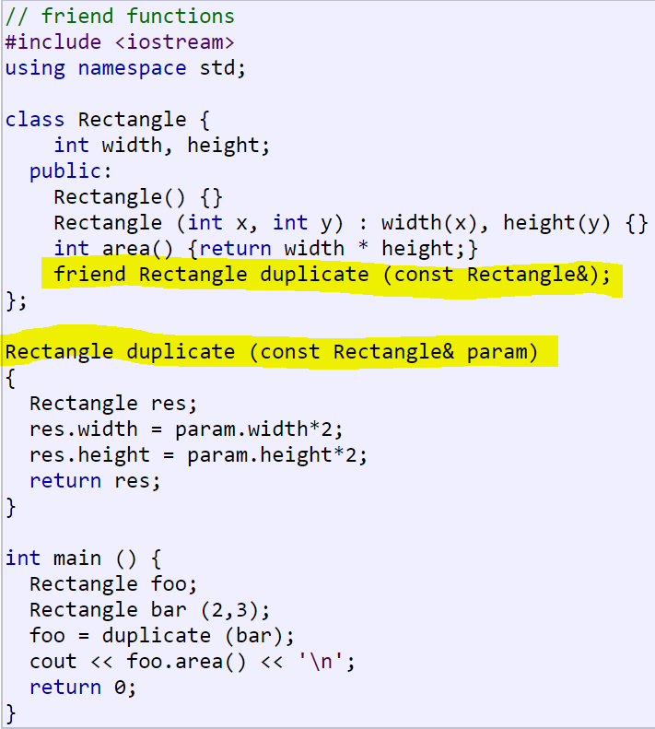
* Declaring a class as a friend: (Notice Square declared, before rectangle so that rectangle can use square in the convert function. In this case rectangle is declared as a friend of square, and can access squares side variable   
  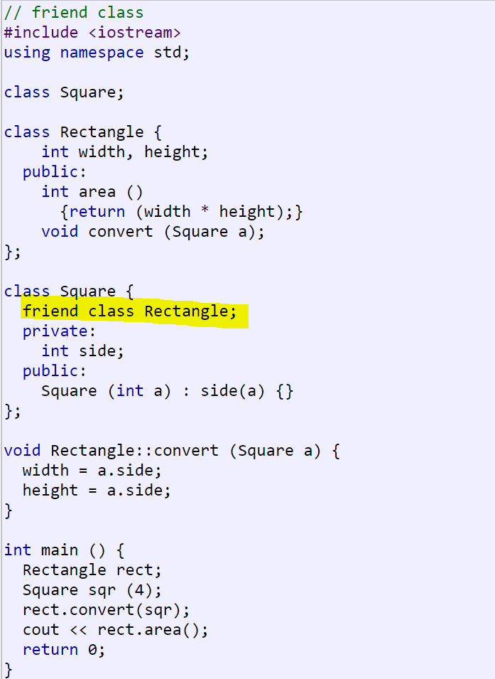

##### Private

Private of course means only accessible in class defining the private members or methods. Also accessible by friends of the class.

##### Protected

Protected members are accessible in the class that defines them and in classes that inherit from that class. Accessible by friends of their class, and by friends of their derived classes.

#### Polymorphism

A class that declares or inherits a virtual function is called a *polymorphic class*.

##### Virtual

* A virtual member is a member function that can be redefined in a derived class, while preserving its calling properties through references. The syntax for a function to become virtual is to precede its declaration with the virtual keyword

Example:

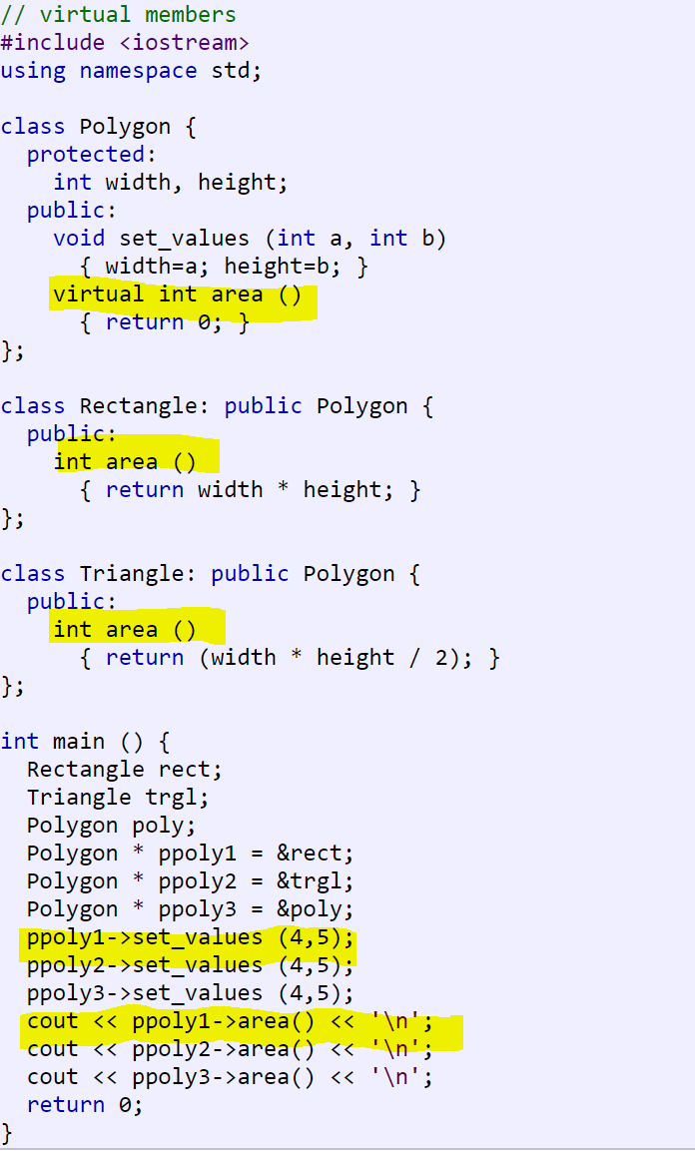

* Notice how this allows us to never have to call rect.area, or trgl.area, we can use the pointers ppoly1 and 2 to call these.

##### Abstract Base Class

* Classes that contain at least one *pure virtual function* are known as *abstract base classes*
* can only be used as base classes, and thus are allowed to have virtual member functions without definition (known as pure virtual functions). The syntax is to replace their definition by =0 (an equal sign and a zero)

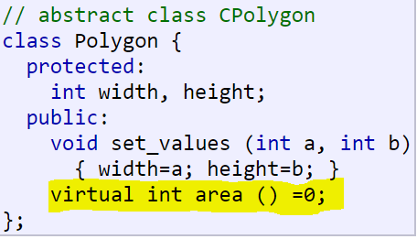

* + The area method has no definition, allowed because it’s a pure virtual
* Abstract base classes cannot be used to instantiate objects. Cannot do Polygon mpolygon;
* Can create pointers to it, and take advantage of all its polymorphic abilities. So Polygon* ppoly1;
* possible for a member of an abstract base class  to use the special pointer this to access the proper virtual members, even though no implementation for the function. Example:   
  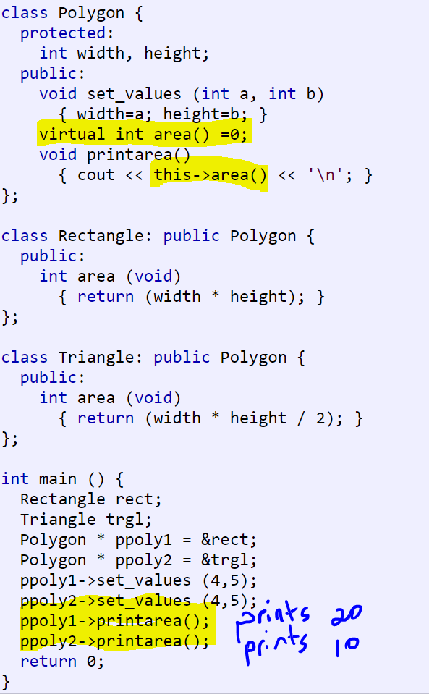

###### This

* Every object in C++ has access to its own address through an important pointer called this pointer.
* value is the address of the object, on which the member function is being called
* Friend functions do not have a this pointer, because friends are not members of a class. Only member functions have a this pointer.

#### Const

* Means value won’t change.
* Only works on class / member functions
* Goes in .h and .cpp file.

|  |  |
| --- | --- |
|  |  |
| Header File | CPP File |

#### Getter / Setter Methods

* Used to access private variables
* Put at top of .cpp file
* Make getter methods const

## Functions

### Return Types

* Void – returning nothing
* Return 0 in main.cpp just says exited without errors

### Side Effects

* Function does more than what it should, does something user doesn’t expect.

## Preprocessor Directives

Tells compiler do this before compiling. Anything with a # (hash).

* #include
  + Use chevrons <> when accessing standard libraries, use “” for own code
* #pragma once – include only once (not a standard, but widely supported)
* #define – does text replacement, for example #define TMap std::map would replace TMap with std::map before compiling – **WARNING** : Bad practice to use #defines / macros generally. Concern is its substituting and can be hard to debug.

## Namespaces

* Syntax: using namespace <namespace>
* Can use using to avoid writing namespace all the time, but of course can get clashing issues if two different namespaces have the same function name.
* Never use in header files

## Pointers

#### References

* Main difference from pointers is can’t be re-assigned, fixed to a memory address
* Can’t be null
* Declaring : int& valRef = val where val is int val =2
* Accessing contents requires no operator, so: polyRef opposed to ptr which is *polyRef
* Accessing address use & so : &polyRef vs ptr: polyRef
* Changing value: polyRef = poly, pointer is of course *polyRef = poly

#### Basics

* & is the address-of operator, and can be read simply as "address of"
* * is the dereference operator, and can be read as "value pointed to by"
* int * p1, * p2; int firstvalue = 5, secondvalue = 15; p1 = &firstvalue; p2 = &secondvalue;
  + *p2 = *p1 - sets values, so secondvalue = firstvalue
  + p1 = p2 – sets memory address, p1 now points to secondvalue
* int *p1, p2 – p2 is a regular int not a pointer, need to do int *p1, *p2

### Arrays

* To set pointer to array, can:
  + Setting to start: ptr=array or Ptr=&array[0]
  + Specific cell:
    - P++
    - P = array + #
    - P = p+# , assuming p already assigned to the array

Consider this code block:

1. int numbers[5];
2. int * p;
3. p = numbers; *p = 10;
4. p++; *p = 20;
5. p = &numbers[2]; *p = 30;
6. p = numbers + 3; *p = 40;
7. p = numbers; *(p+4) = 50;

* line 3 sets numbers[0] to 10
* line 4 moves the pointer’s memory location by one, so to numbers[1] and sets that to 20
* line 5 sets pointer to memory address of numbers[2], ie third element and value 30
* Line 6 sets memory address to 4th element / numbers[3] and value 40
* Line 7 resets to first element numbers[0], then moves it to the 5th element numbers[4] and sets to 50
* Both of this are valid:  
  a[5] = 0; // a [offset of 5] = 0

*(a+5) = 0; // pointed to by (a+5) = 0

### Initialization

Consider:

|  |  |
| --- | --- |
| int myvar;  int * myptr = &myvar; |  |

Also valid:

|  |  |  |
| --- | --- | --- |
| 1 2 3 | int myvar;  int * myptr;  myptr = &myvar; |  |

When pointers are initialized, what is initialized is the address they point to (i.e., myptr), never the value being pointed (i.e., *myptr). Therefore, the code above shall not be confused with: 

|  |  |
| --- | --- |
| 1 2 3 | int myvar;  int * myptr;  *myptr = &myvar |

### Arithmetic

* as a prefix, the increment ++ happens before the expression is evaluated
* as a suffix, the increment ++ happens after the expression is evaluated. This also applies to expressions incrementing and decrementing pointers, which can become part of more complicated expressions that also include dereference operators (*).
* Recall operator precedence rules, postfix operators, such as increment and decrement, have higher precedence than prefix operators, such as the dereference operator (*). So *p++ is equivalent to *(p++). And what it does is to increase the value of p (so it now points to the next element), but because ++ is used as postfix, the whole expression is evaluated as the value pointed originally by the pointer (the address it pointed to before being incremented).
* four possible combinations of the dereference operator with both the prefix and suffix versions of the increment operator (the same being applicable also to the decrement operator):
  + *p++ // same as *(p++): increment pointer, and dereference un-incremented address
  + *++p // same as *(++p): increment pointer, and dereference incremented address
  + ++*p // same as ++(*p): dereference pointer, and increment the value it points to, a way to increase value
  + (*p)++ // dereference pointer, and post-increment the value it points to
* Example: *p++ = *q++;
  + Same as:  
    *p = *q;  
    ++p;  
    ++q;
  + Why: Because ++ has a higher precedence than *, both p and q are incremented, but because both increment operators (++) are used as postfix and not prefix, the value assigned to *p is *q before both p and q are incremented. And then both are incremented.

### Const

* a pointer to non-const can be implicitly converted to a pointer to const. But not the other way around. Example:  
  int x;  
  int y = 10;  
  const int * p = &y;  
  x = *p; // ok: reading p  
  *p = x; // error: modifying p, which is const-qualified
* types:
  + int x;

int * p1 = &x; // non-const pointer to non-const int

const int * p2 = &x; // non-const pointer to const int

int * const p3 = &x; // const pointer to non-const int

const int * const p4 = &x; // const pointer to const int   
**NOTE**: const qualifier can either precede or follow the pointed type  
const int * p2a = &x; // non-const pointer to const int  
int const * p2b = &x; // also non-const pointer to const int

### Access

* Can do (*SomeActor).GetName() - *SomeActor dereferences (value pointed to) pointer, ie follows it. The . then access
* Of course can use -> to dereference/follow and access: SomeActor->GetName()

### Void

The void type of pointer is a special type of pointer. In C++, void represents the absence of type. Therefore, void pointers are pointers that point to a value that has no type (and thus also an undetermined length and undetermined dereferencing properties). This gives void pointers a great flexibility, by being able to point to any data type, from an integer value or a float to a string of characters. In exchange, they have a great limitation: the data pointed to by them cannot be directly dereferenced (which is logical, since we have no type to dereference to), and for that reason, any address in a void pointer needs to be transformed into some other pointer type that points to a concrete data type before being dereferenced. For example:

void increase (void* data, int psize)

{

if ( psize == sizeof(char) )

{ char* pchar; pchar=(char*)data; ++(*pchar); }

else if (psize == sizeof(int) )

{ int* pint; pint=(int*)data; ++(*pint); }

}

### Null

Expressed as a 0 or nullptr, So:

int * p = 0;

int * q = nullptr;

NOTE: older coding uses NULL, which is defined in standard library

### Functions

Pointers to functions are declared with the same syntax as a regular function declaration, except that the name of the function is enclosed between parentheses () and an asterisk (*) is inserted before the name:

// pointer to functions

#include <iostream>

using namespace std;

int addition (int a, int b)

{ return (a+b); }

int subtraction (int a, int b)

{ return (a-b); }

int operation (int x, int y, int (*functocall)(int,int))

{

int g;

g = (*functocall)(x,y);

return (g);

}

int main ()

{

int m,n;

int (*minus)(int,int) = subtraction;

m = operation (7, 5, addition);

n = operation (20, m, minus);

cout <<n;

return 0;

}

So minus is a pointer to a function that has two parameters of type int. It is directly initialized to point to the function subtraction

## Memory

This is to better understand ::, ->, and . etc… Consider this:

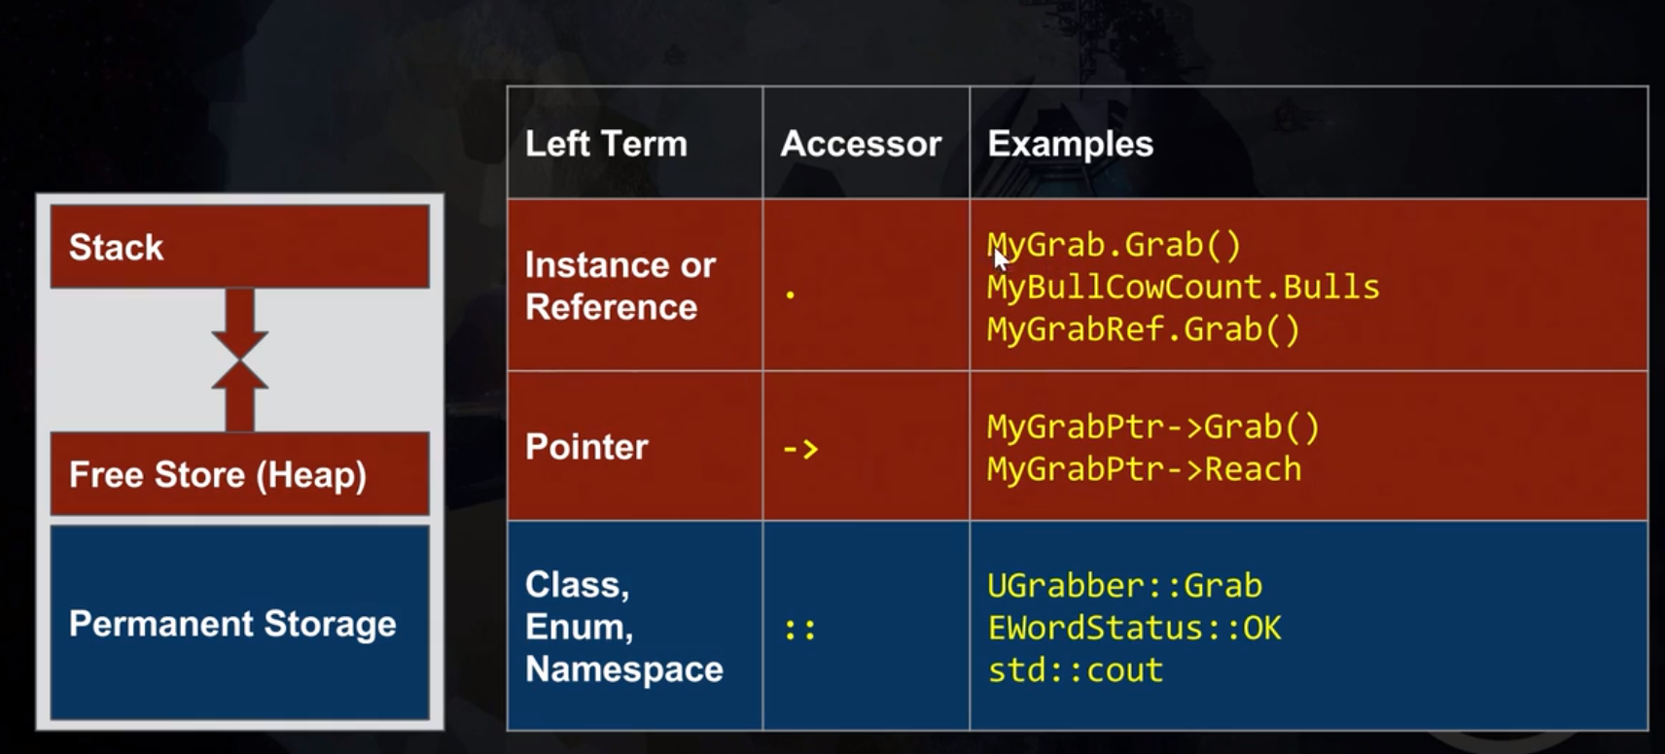

* Consts, functions and anything else known at compile time go in the blue permanent storage
* Things that vary at run-time use dot and arrow, i.e. “.” Or “->”
* So if I put &UGrabber::Grab, then I’m passing the address of the function in permanent storage

## Libraries

### iostream

#### std

* cout – prints to screen
* cin – for input, reads up to first space
* endl – end line, flushes buffer, opposed to adding a \n which won’t flush buffer
* getline(iostream/where get from, variable/where put the result) – read through all spaces and discards everything after the first newline it encounters.

### string

* contains the >> operand

## Magic Numbers

* Numbers you hard code into the program that are random in selection. I.E. Choose 6 letters, or Can you think of these 5 words? Vs Interstate 10 or something that won’t change in the real world

## Conditionals

Avoid comparing floats, inaccurate over time. Use int or double

### Switch

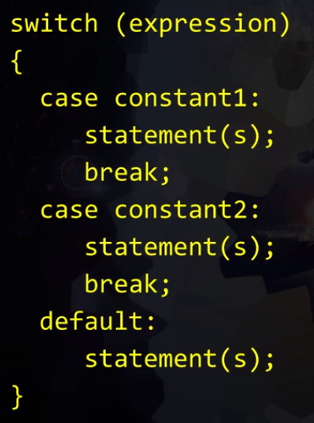

## Constants

### constexpr

* Evaluate at compile time, doesn’t change once program runs. Guarantees you know the value at compile time.
  + Example:  
    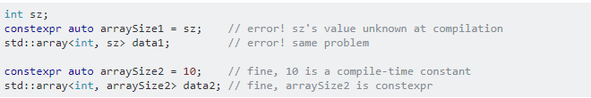
* constexpr <type> <NAME_IN_CAPS> = <value
* All constexpr are const, but the reverse isn’t true

### const

* a constant value but doesn’t guarantee to have values known at compilation.
* Use when the value of a “variable” that is initialized with a value that is not known at compile time but never changes after initialization

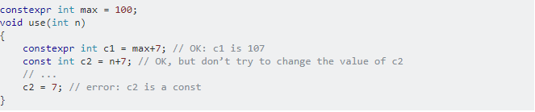

## Booleans

* == equals
* && and
* || or
* [n] character of string
* ‘ ’ for characters and “ ” for strings

## Dependency Mapping

Look at cpp files and can map out what depends on what

# UNREAL

## AI

### Algorithms

#### A* / Dijkstra

These are similar except A* is directed and uses heuristics in trying to find the shortest path. It guess’s which direction to look rather than finding shortest path to every point like Dijkstra. The idea is to weight the cost of an edge to a node + cost of previous node. The lowest weight wins.

### PathFinding

#### Overview

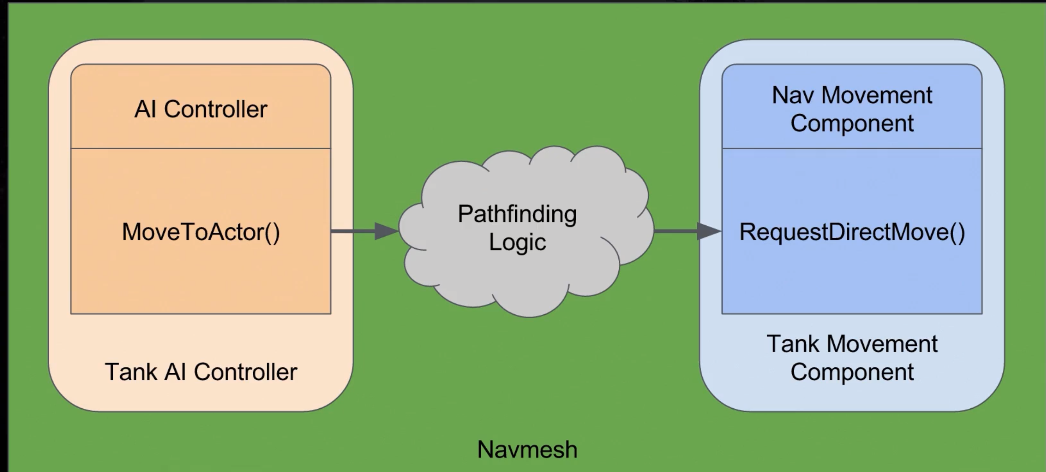

* Function of AI (*AAIController)* is MoveToActor. We can give that the player tank. Then the pathfinding logic uses navmesh and calculates how to get to player. Then it gives a vector per frame of the direction to go to reach the tank. Note that Movetoactor does a lot in the function under the hood. In effect you call the function, and whereever you have the NavMoveComponent call RequestDirectMove which gets the vector

#### NavMesh

Probably using A* algorithm

##### Adding

* In Modes, search for nav mesh or look under Volumes. It’s a Nav Mesh Bounds Volume
* Green is where you can go, red is uncalculated and non shaded can’t go
* To See: Show > Navigation or hit P in viewport

## Landscapes

* Use about 1/6 or less of storage of static mesh (28 bytes or so per vertex, while landscape uses 4)
* Supports LOD and streaming
* Up to 8K (8196) heightmaps for import
* Good tools for sculpting
* Works well with mini-maps
* Fill world maxes number of components which is 32x32

### Materials

* Use a material, with a layer blend. Connect two materials to the layer. When you are ready to paint into the layers, hit the plus circled red if it’s not already set:  
  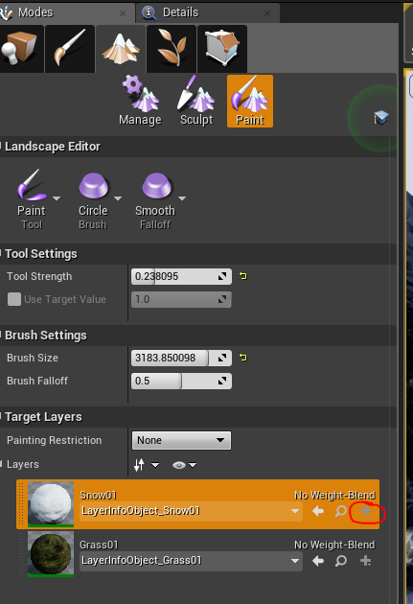

#### Textures

* Create a Texture sample, and a Landscape Coordinates (provides the uvs)  
  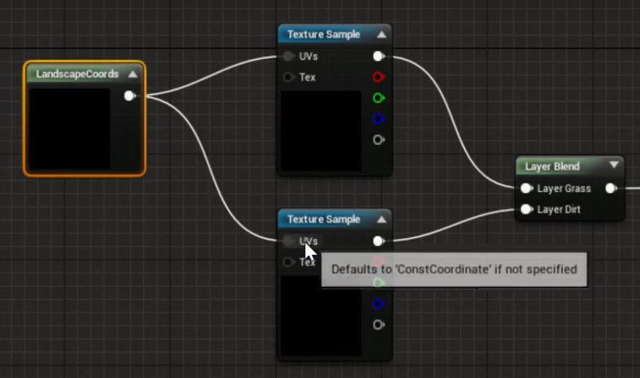

#### Flat Shading

* Take the cross product of x and y to get a normal:

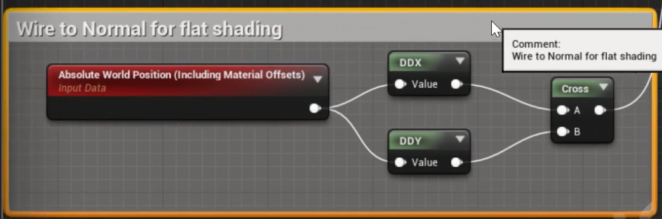

#### Exporting Height Map

* Can export or import height map by right clicking on the HeightMap in landscape mode:

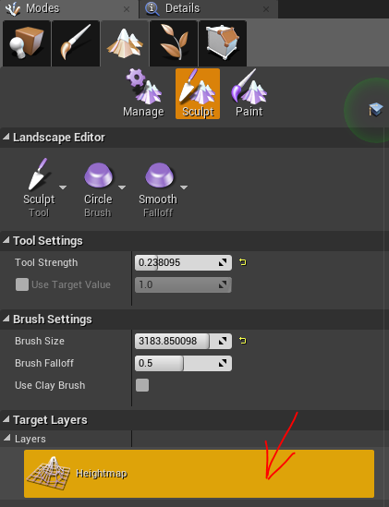

### Changing Poly Count

* Go to Modes > Manage > Click the selection Tool and in the drop down > Change Component Size

Scale  
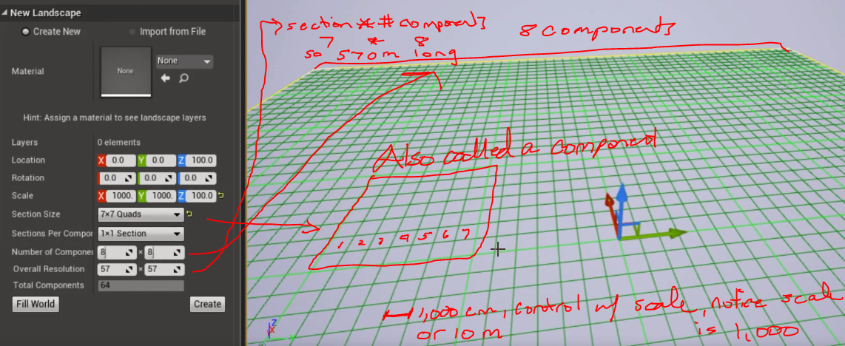

* Another scale example. To create a ½ meter quad, and a landscape 1km in size (1,000,) with 98x8 components:
  + Scale = 50. Since its cm, and 100 cm in a meter, ½ a meter is 50 cm
  + Set components to 8x8
  + Then set a section size, which is x * components = overall resolution, so 8x = 2041. This is x = 255
  + Total size then is 2041 units and each unit is 0.5 so ~ 1000m

## Selecting a Template

* If doing C++, go with the C++ tab obviously, since can also derive blueprints.

## Blueprints or C++

When to use which

1. Define bases classes in C++. From my Example it would Character, Item, Power (like spells, or special attack), Weapon, Effect (persistent object that affect actors in some way). You got the idea.
2. I create basic implementation of each class in C++. Those implementations do not contain any game mechanics specific code. At the start each class is pretty small. For example, Effect class implements Ticker, events (like applied, removed, tickEverFrame, TickOnSet. etc.
3. Then I implement specific game mechanics inside Blueprint which derive from specific object.
4. Back to C++ code. I refactor blueprint implementation into functions, in each object, or into Blueprint Library functions that are not dependent on specific object.
5. This way I can simplify how Blueprints are implemented, as common tasks, are encapsulated inside specific functions, that simply can be dropped inside blueprint and set parameters. I refactor blueprints once I have implemented functions in C++.

Some tasks are easier made in C++. Some complexities of blueprint implementation can be easily hidden in C++ and exposed as single function. C++ have compilation time, which makes iteration slower. Blueprint compile at instant can be ready for testing very quickly.

Example:

1. Make your Lego Pieces inside C++.
2. Build your game from Legos inside Blueprint.

## Components

* “has a” relationship
* Use this for ‘has a’, and inheritance for ‘is a’
* These are recyclable, reusable, so very powerful.
* Add a C++ via the details tab when you have an object selected.
  + When giving the name, don’t put “U” prefix, unreal will do this  
    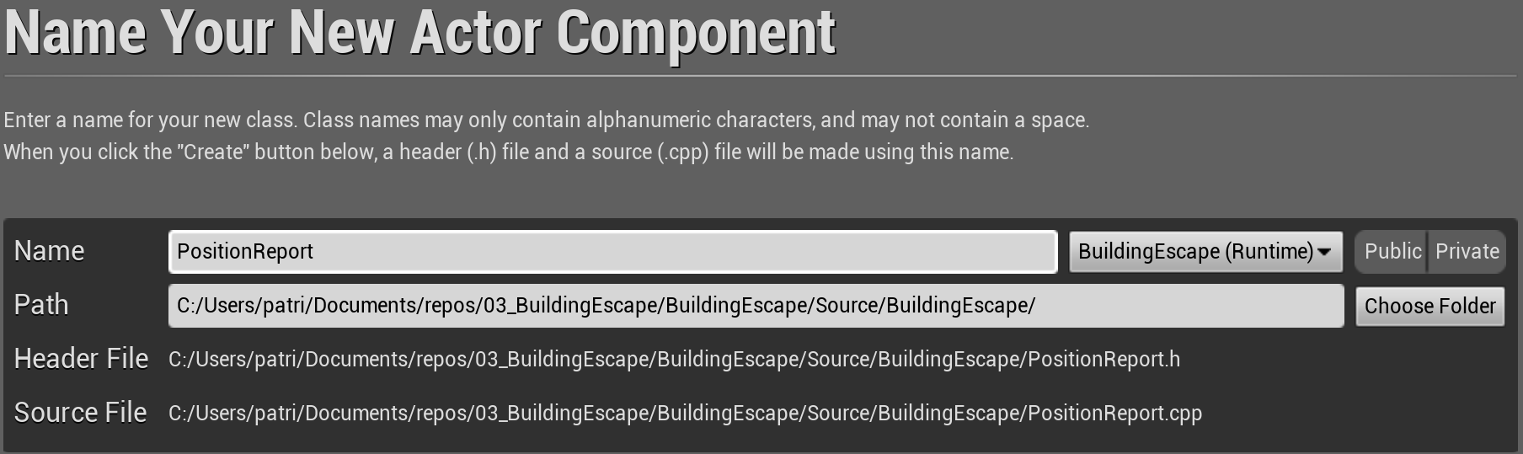

## Adding Content within Editor

In content browser, click add new > Add feature or Content Package

## Copying Between Projects / Migration

Right click on an asset (then Asset Actions > Migrate) or folder (Migrate)

## Removing Assets

### Redirectors

These are like aliases, and don’t show by default. They will cause a warning when deleting an asset that references exist. You can check by Filter > Other Filters > Show Redirectors (in content browser):

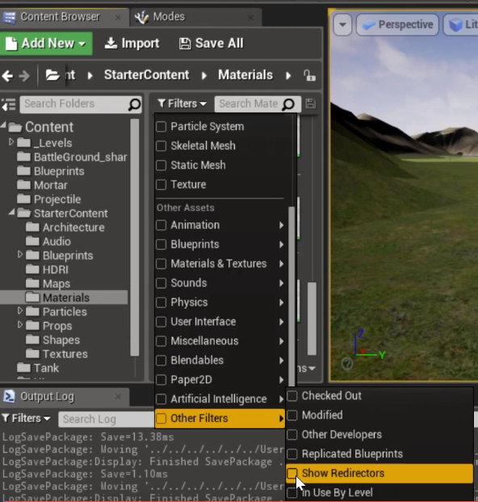

#### Removal

Right click on a folder in content browser and select Fix Up Redirectors

## Reference Viewer

Can use this to see all dependencies of assets.

## Types

* Don’t use int, use int32
* FString (mutable) – only type that allows manipulation, don’t use for display strings
* FText - for user interaction, display strings
* Enumeration – suggests put in own namespace and use class  
  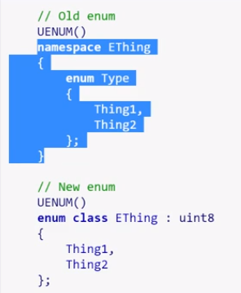
* Booleans – start with b, example bGameWon
* Maps are TMap
* Pointers – Unreal does type/class* pointerName, although any of the below are valid  
  

## Game Mode

Includes anything a player starts with, number of lives, time limits, score needed to end game, etc.. Basically the rules of the game.

## Player Controllers

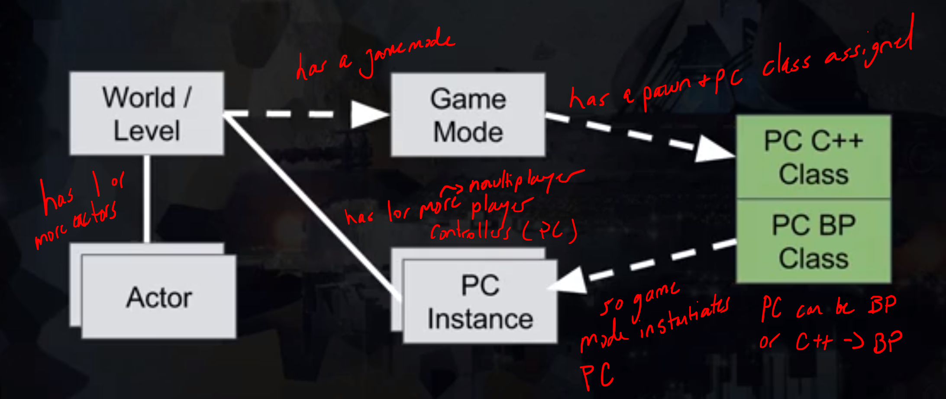

## User Input

By default, set to game mode only. So UI won’t do anything. This is how it works and can see why UI ignored by default:

|  |  |
| --- | --- |
|  | * Player Mapping: where if you map say ‘space bar’ to jump. I.e.: * Input enabled actor: Disabled by default, but can have actor auto receive input, say you have an input manager: |

### Show Mouse Cursor For UI

Mouse cursor will not show as moving by default, that’s why we add in blueprint where setting up UI, a set show mpuse cursor node. If it’s not showing disable context sensitive checkbox. This node will enable the mouse to work with UI, but disable for gameplay.

### Modes

***Always plug the player controller into the target of an Input Mode node. Example below shows Game only but true for all input mode nodes. OTHERWISE WEIRD SHIT WILL HAPPEN!***

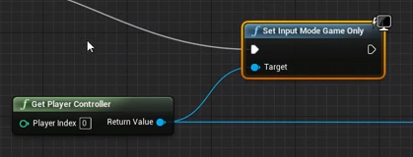

### Game Only

* Don’t ever want to use a set show mouse cursor, because will absorb actions and not work with game, just ui.

### UI Only

* UI takes all input – keyboard, mouse, gamepad – none passed to player controller
* Will not see mouse unless use a set show mouse cursor. Show really always need to do this.
* Set Input Mode to UI Only node has a lock mouse to viewport. Note that it lock/constrains to screen for the UI widget it is attached to

### Game and UI

* Allows you to combine UI and game. So you can click on user interface with mouse, receive keyboard and gamepad input for player controller, and use mouse buttons for player.
* Can use set show mouse cursor
* Hide mouse during capture allows mouse to show on screen but to leave viewport/screen: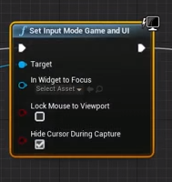

## Blueprint

* Saving doesn’t reflect all changes made in editor, need to compile. Note compile also saves.
* To make a component the root (instead of the default scene root), just drag the component on top to replace
* Can have as many event graphs as you want, but only one can have BeginPlay.
* Cannot rename the main EventGraph

### Callable Vs Pure

Blueprint pure doesn’t have an exec pin, its used for functions that do no modify game state. An optimization vs callable which do have exec pins.passing

### Organization

Use reroute nodes – like a null node – specifically for organization

### Output to More than One node / Sequence Node

Use the sequence node to output to more than one node. For example send BeginPlay to more than one event

### User Interface

Basic setup is to create a UI widget blueprint. Content Browser > Add New > User Interface > Widget Blueprint. Open blueprint editor and make your interface. Next create a player controller blueprint since more than likely that is where you want it. From the player’s view. In that blueprint create a beginPlay. Right click and search for create widget. In this node select the UI blueprint. This creates an instance of it for using. Then create an add to viewport node and connect to the widget node:  
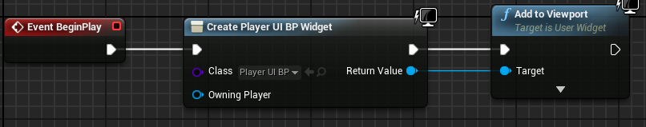

Finally connect to the game mode, either base one or one you created.

#### Anchors

* The anchor allows you to control how the element shows on screen.
* Can preview how will look on various devices by using the screen size menu

#### Start Screens and Other Screens

1. Can do the Screen UIs in same level as game, and hide/unhide UI elements. Can get hard to manage.
2. Create Screen UI in another level.

##### Start Screen

* Create the UI widget
* In the level’s blueprint add begin play, a create widget that it connects to and add to viewport. Also put a set show mouse cursor.
* Also create a custom event, this will be used to communicate with the UI blueprint

##### Start Button

* On the button in Designer view of Blueprints, at the bottom are Events

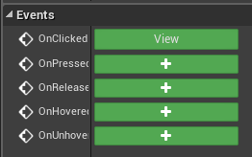

* Click a plus to add one, takes you to the blueprint graph for the UI (not the level BP).
* Using the On Clicked event, assign an action such as open level.
* Using the custom event from the level blueprint, connect to a set input mode UI only. Don’t forget to set the player controller and in widget focus to the start button.

Overview of the two blueprints:  
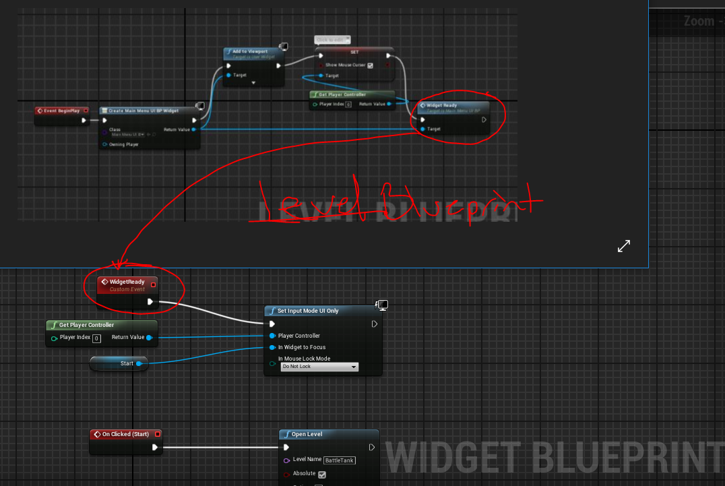

### 3rd Person Camera System

The idea is to create an object that allows for rotation around z, and a rotation around y to stabilize camera so it doesn’t roll all around like a ball socket. We are restricting rotation to specific axises.

**We setup in the pawn blueprint.**

* Create the following
  + a scene- used to control azimuth (horizontal rotation around Z)
  + a spring arm – used to control elevation (vertical rotation around Y) **NOTE: disable inherit roll in details under camera settings**
  + a camera
* Parent as follows:
  + Scene
    - Spring Arm
      * Camera
* Create axis mappings in project settings, probably aim and elevation tied to mouse x/y and gamepad thumbstick x and y
* Setup blueprint as follows (note azimuth gimbal is the scene created above):

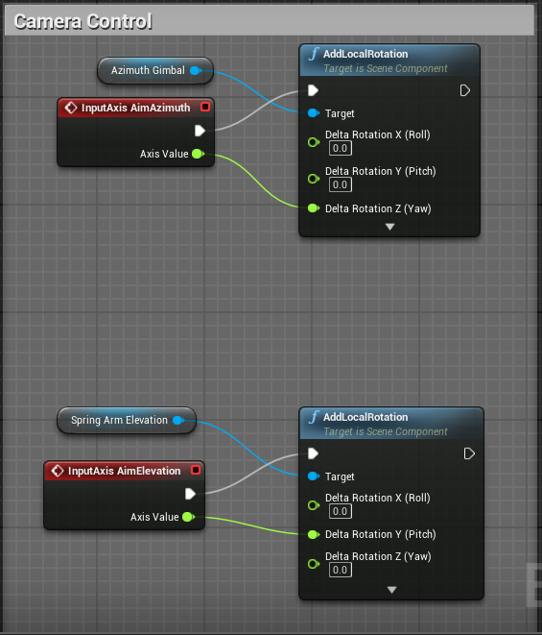

### 1st Person and 3rd Person Camera

You can easily switch cameras using toggle activate nodes. Create another camera, place it and make sure you toggle auto activate off (otherwise it will get a random viewport). That is if the 3rd person camera is the start camera. Then bind input (for example shift+c on keyboard) and place two toggle activate nodes:

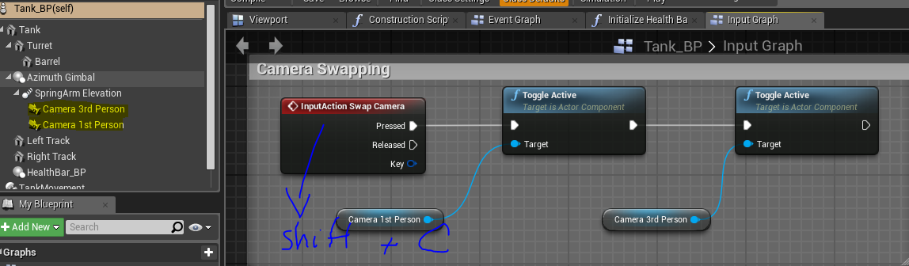

### TimeLine Node

* Double click the node to open track editor.
* Offers different types of tracks such as float, vector , event
* Editor:  
  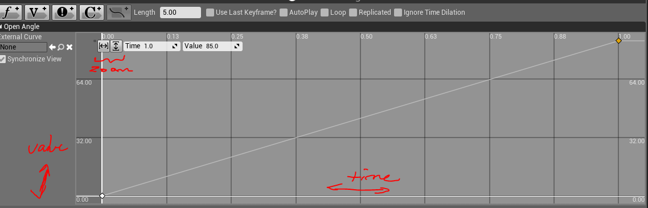
* A note about animation length. The animation will run for the number specified in Length (highlighted below). Probably don’t always want to match the last keyframe (circled blue) time to the length, so can just check use last keyframe (circled red). In otherwords, the animation below is 5 seconds, we have a key frame at time 0 and 1 seconds. Really want the animation length to be just 1 second.

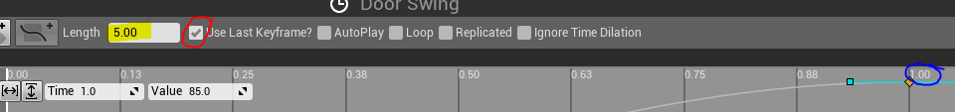

### New Game Modes

#### Method 1

* In content Browser Go to C++ folder. There will be a Game Mode in there. Can right click and select Create a blueprint class…

#### Method 2

* In Blueprint menu, go to world override > Create

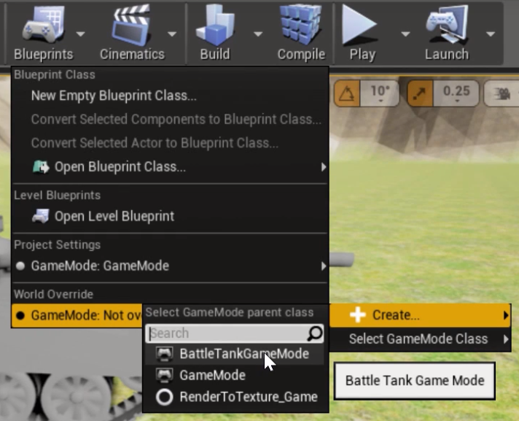

## Sockets

### Setup

* Make sure pivot is at origin or where you want to attach in the software you built it in.
* Put the base mesh down in a blueprint via add component static mesh
* Open Static Mesh Editor
* Create a new socket in the socket manager of the static mesh editor and select the desired mesh for preview to position, clear once done
* Now back in Blueprint, go and add another static mesh component, and drag under the base mesh so it’s a child.  
  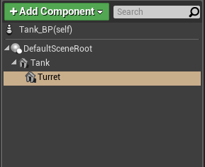
* With the child mesh selected, In the sockets, set to the socket created above. **WARNING**: Must parent first for the socket to be availble  
  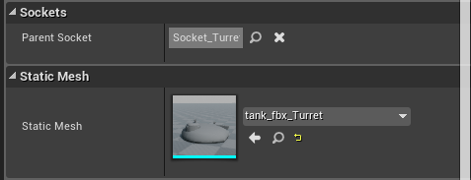

## Input

### Bindings

Settings > Project Settings > Engine > Input

* Action Mappings for on/off actions
* Axis Mappings for analog values like joystick
* Can remap keys too

PawnInputComponent

derived from actor class, comes into existence at runtime (when hit play)

### Fly By Wire

Replaces manual control system with an intention-based system. I.e. turn the tank right and it goes right by adjusting what is needed. Don’t have to control both of its tracks for instance. It does what’s needed to make intention happen.

## Collisions

### Primitves / Simple

Can edit values without manipulators:

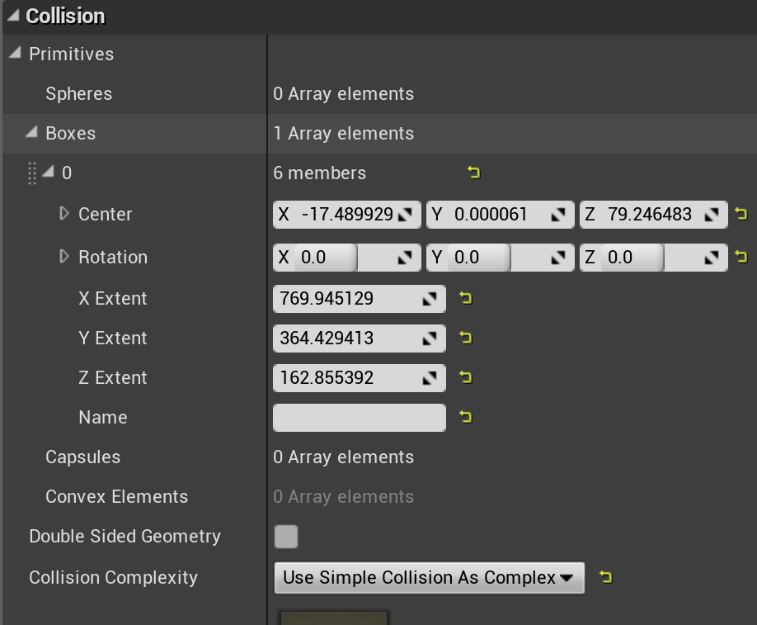

### Filtering

Applies to line tracing too

#### Three Response Types

* Block
* Overlap
* Ignore

#### Trace and Object Channels

Unreal supports both the object deciding the types of queries to collide with and queries deciding what kinds of object they are looking for. Example:

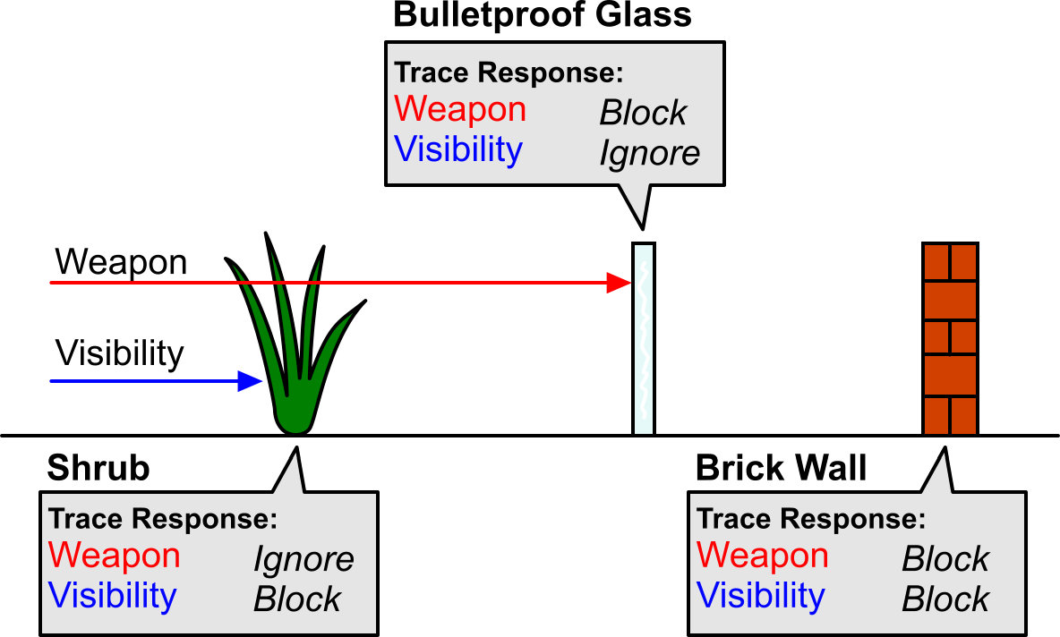

* Approach with Trace Channels, then create weapon and visibility queries. Objects deciding query to respond to.
* Approach with Object Channels, then the game code has to know what types of object to query for, and game could need a huge number of different types to handle all these situations! It also allows us to make ‘spot fixes’ in content later on, instead of changing the calling code itself and possibly breaking other things.
* Example where Object Query is good: an explosion going off, and you want to quickly find all objects of type ‘Pawn’ or ‘PhysicsBody’ within a certain radius. When you do this kind of query, you can specify multiple Object Channels.

##### Built-in Trace Channels

* Visibility
* Camera

##### Built-in Object Channels

* WorldStatic
* WorldDynamic
* Pawn
* PhysicsBody
* Vehicle
* Destructible

##### Custom

Add your own under Edit -> Project Settings -> Collision, though you are limited to 32 in total.

#### Moving Objects

* Each object knows its own Object Channel, plus a list of how it responds to other Object Channels.
* Use the least blocking interaction.

Consider this chart and scenario:

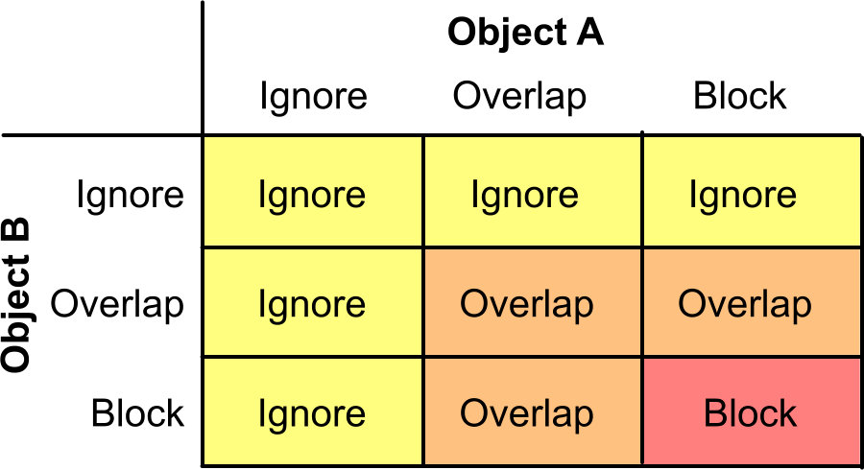 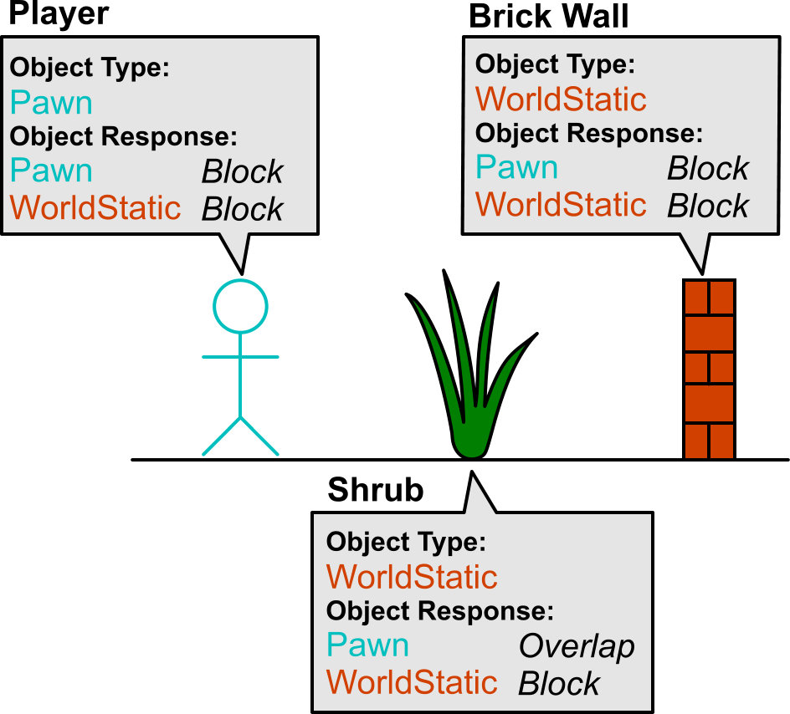

The player moves forward. First, he will overlap the shrub. The Player is of type Pawn, and the Shrub wants to Overlap that. The Shrub is of type WorldStatic, and the Player wants to Block that. Checking the chart, the final result is Overlap! Similarly the Brick Wall and Player both want to Block each other, so the player walks through the Shrub (generating an Overlap event) and is stopped by the wall (generating a Hit event).

#### Presets

* Each Preset contains an Object Type, and a response to each Trace and Object Channel in your game. When you select an object in the level, you will see a simple dropdown, allowing you to select a Preset:  
  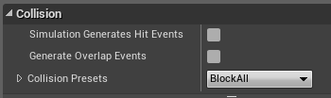
* Choosing custom opens this up:

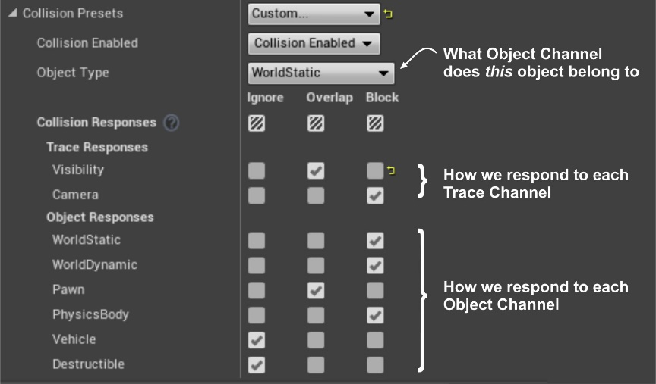

#### Simple and Complex Collision

* Complex Collision uses actual geometry.
* Each mesh can have both.
* Simple Collision is using spheres, boxes, capsules and convex hulls
* When you perform a collision query, you tell UE4 what kind of geometry you want to collide with
* View mode in editor to see simple collision geo (Player Collision) and complex (visibility):  
  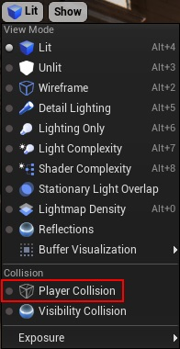

#### Trace Channels

##### ECC_Camera vs ECC_Visibility

Camera will ignore the UI elements, visibility won’t

#### Optimizations

* We can actually stop looking for collisions after the first blocking collision, which is a good performance optimization - imagine firing a gun with a range of 1km at a brick wall 1m in front of you, we just skipped 999 meters of work!

## Physics

In Project Settings have defaults for scene

### Auto Weld

Under physics on object, tells it to combine with parent to make one rigid body

### Physics Materials

Can control physics attributes

#### Landscapes

Set in the layer object:

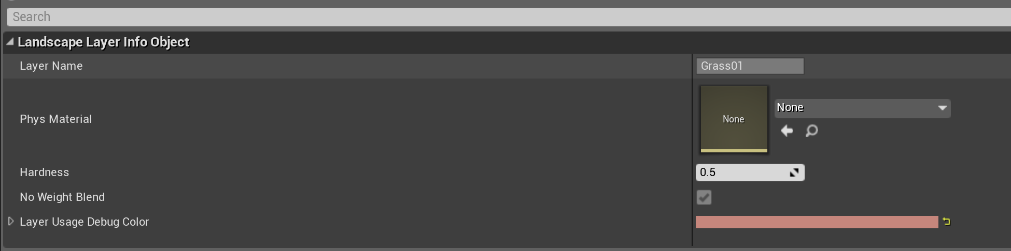

#### Actors

Under collisions assign

### Friction

There is a mode option

* Average combines and averages friction of objects
* Min – takes smaller of the values

## Build System

Unreal uses c sharp (.cs) as an independent build system that then generates project files, so .sln, which then builds binaries  
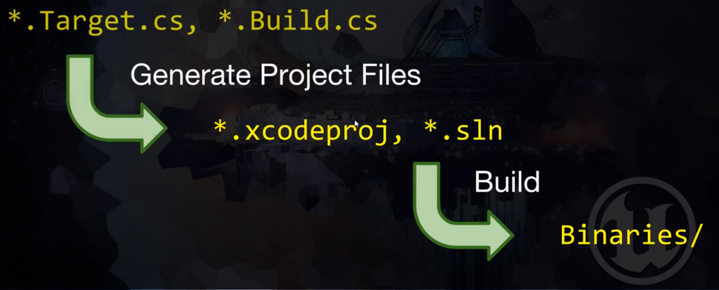

* .cs files here in source folder of project:  
  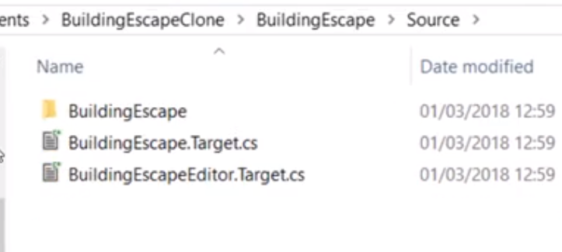

### Updating to a new version of unreal

* Download new version, then open your project in it. It should have a more options at the bottom that lets you convert. Be sure to backup/commit first.

## Visual Studio

Interaction between Unreal and Visual Studio

### Basics

* Unreal is responsible for building VS solution.
* Include what you use approach to improve compile times. Have to include what you need. Change happened in 4.17: <https://docs.unrealengine.com/en-us/Programming/UnrealBuildSystem/IWYUReferenceGuide>
* Can compile vs code in unreal by pressing the compile button.
* If you get an error loading VS project, can rebuild project files by:  
  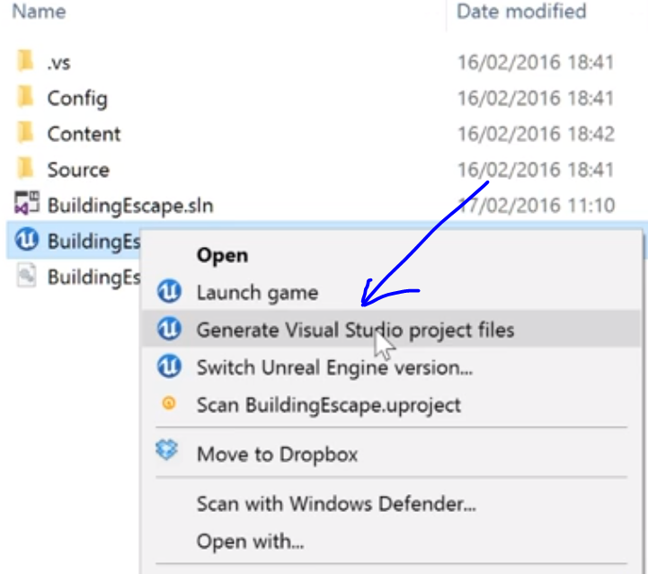

### Includes

* Any code generated from Unreal for you should always have a.generated.h as the last include in the header file. For example, this Position Report class I created in Unreal when adding a c++ component:  
  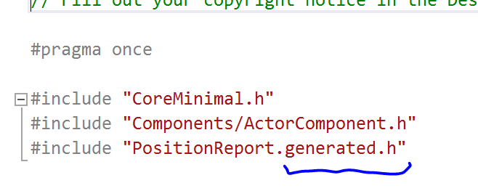

### Accessing Code in Unreal

* In details tab can select component, in this case the c++ component, and show in content browser  
  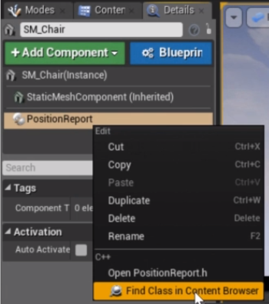
* Then double click (it will already have the c++ component selected.

### Errors / Debugging

* Use of undefined type
  + Means missing a header file, look at the type, then search either in google or unreal documentation for the type. Example, you get use of undefined type ‘AActor’ searching in google for unreal AActor takes you to the AActor page, and at bottom of page is the header file to include. Usually only need to include two levels. For instance, #include "GameFramework/Actor.h" is really #include "Runtime/Engine/Classes/GameFramework/Actor.h"

## Unreal C++

This section talks about how unreal relates to C++. Unreal has macros that help the Unreal Header Tool convert your code into code unreal understands.

### Finding Example Code

Try Looking in IDE, in visual studio for example search the entire solution for a function name. In this case looking for grabcomponent example of physics handler class.  
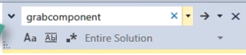

### Resetting the Project

* Check out or reset to a working commit
* Deleting derived files – Intermediate, Saved, Binaries, and the .sln – leave config, content, and source folders
* Open unreal to recreate .dlls etc.. for unreal
* Generating IDE project Files (right click in explorer and select regenerate project files)

### Removing a C++ Class

* Delete source files and remove from project
* Rebuild Visual Studio project files
* Delete Unreal’s binaries folder
* Re-open editor and let it rebuild caches

### Constructors and Begin Plays

#### Creation order

* Runs in this order:
  + C++ Constructor
  + Blue Print Construct Script
  + Blue Print Begin Play
  + C++ BeginPlay
* Doesn’t run all C++ constructors first, etc… Does it object by object (random order)
* On Level Load vs running from the level open in editor
  + On level load, AI objects will run Blueprint construct, but if level open in editor they won’t

#### C++ Begin Play and Blueprint Begin Play

**MUST call Super::BeginPlay() in C++ Begin Play or else blueprint begin play won’t be called!**

### Delegates

Delegates allow you to call member functions on C++ objects in a generic, yet type-safe way. Using delegates, you can dynamically bind to a member function of an arbitrary object, then call functions on the object, even if the caller does not know the object's type. Can pass by value, but not recommended due to memory consumption. Pass by reference. Three types:

* Single-Cast
* Multi-Cast - Multi-cast delegates have most of the same features as single-cast delegates. They only have weak references to objects, can be used with structs, can be copied around easily, etc. Just like regular delegates, multi-cast delegates can be loaded/saved, and triggered remotely; however, multi-cast delegate functions cannot use return values. They are best used to easily pass a collection of delegates around. Events are a specialized type of multi-cast delegate with restricted access to the Broadcast(), IsBound(), and Clear() functions.
* Dynamic - Dynamic delegates can be serialized, their functions can be found by name, and they are slower than regular delegates.

**For Example:**

The Setup:

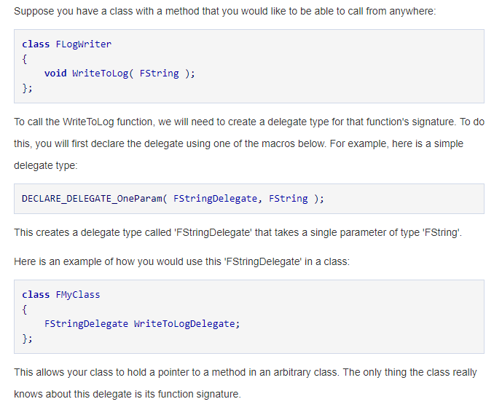

**Usage:**

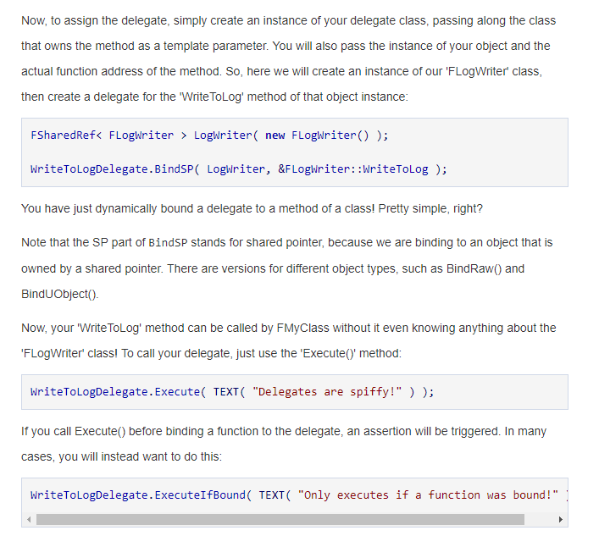

#### Declaration

Unreal provides macros, consult documentation for bets one depending in usage.

#### Payload Data

Arbitrary variables that will be passed directly to any bound function when it is invoked. This is really useful as it allows you to store parameters within the delegate itself at bind-time. All delegate types (except for "dynamic") supports payload variables automatically.

#### Setup A Multicast Dynamic Delegate

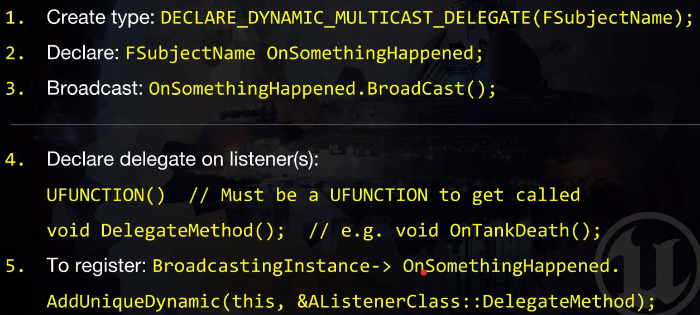

##### An Example

A tank wants to let the player and ai controllers know it died

**The Tank (The Subject)**

In header file: It declares a delegate outside class, then creates an instance of the delegate.

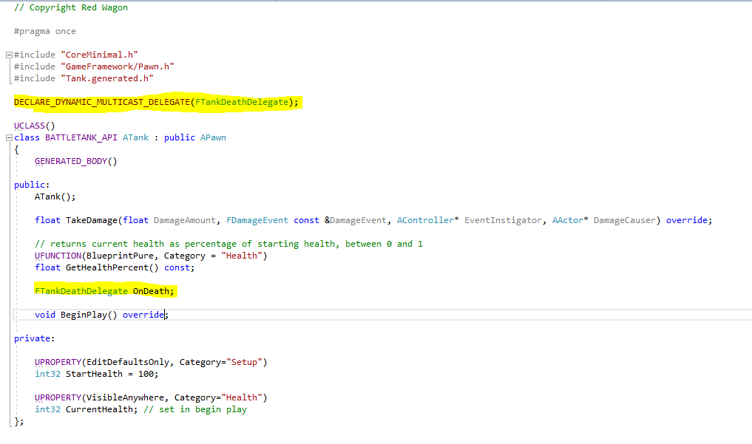

In CPP file: calls broadcast on the delegate instance

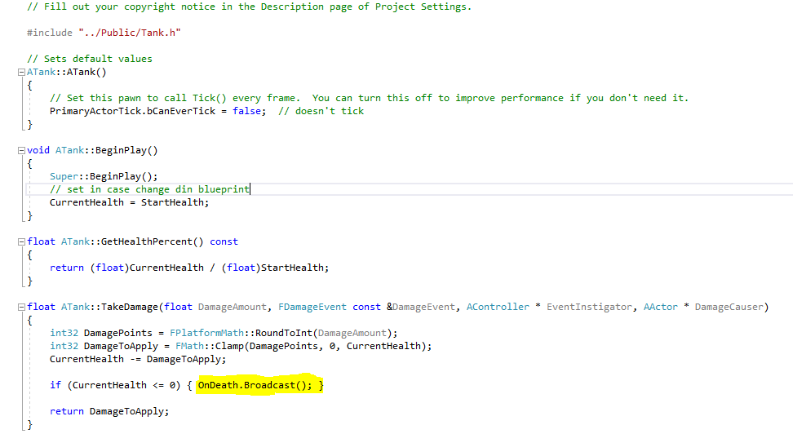

**The Controllers (Observers)**

For sake of brevity, only showing AI setup:

In Header File: Declare a function that will act on notification from tank

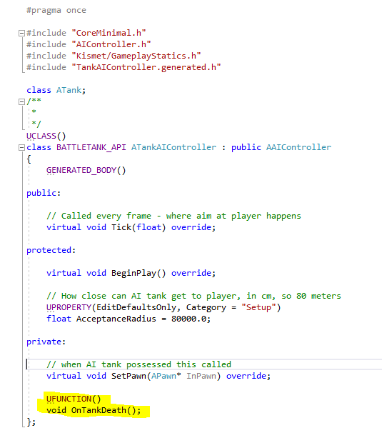

In CPP File: Just showing relevant functions. Note we do this in SetPawn and not BeginPlay because we know for sure the pawn is possessed in SetPawn. Here we subscribe to the Tank notification and say what should happen on notified (our callback function). Then we implement the function callback when notified.

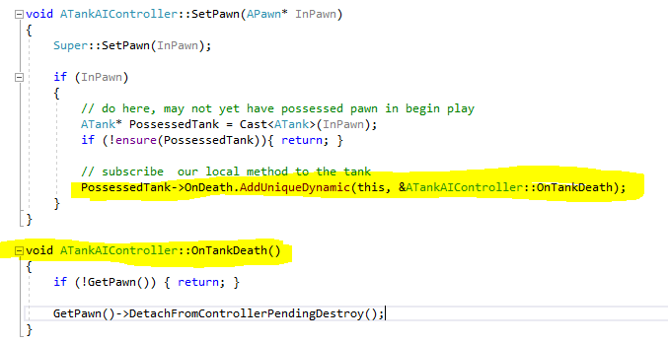

### Enums

Format (prefix with E):

UENUM()

enum class Ename : type

{

Thing1,

Thing2,

….

};

Assigning:

Ename VarName = Ename::Thing2;

### Functions

#### FindComponentByClass

Works by looking for the component giving a class name, for example look at the grabber code under game development. In Unreal we added a physicshandle component to the pawn blueprint. In C++, we can get that handle using this function by typing GetOwner()->FindComponentByClass<UPhysicsHandleComponent>(); Note we are using a generic function call

### Classes

* Prefix with F for user defined classes
* A Prefix is for Actor derived classes
* U prefix is for UObject derived classes
* To make a class available in blueprints use BlueprintSpawnable like (ignore hidecategories, see Properties):



#### Documenting

##### Showing description in unreal for class

In C++ put description in highlighted area:

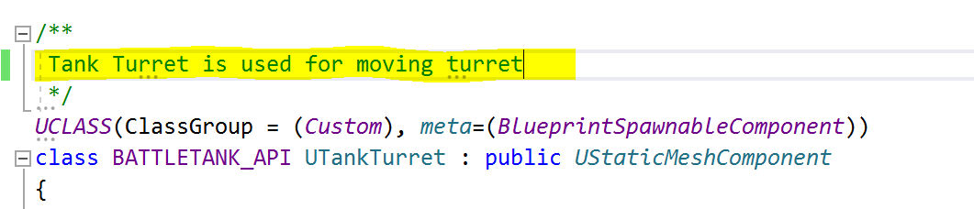

Then in Unreal you see:

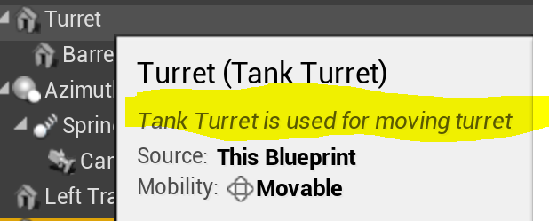

##### Showing Description for functions

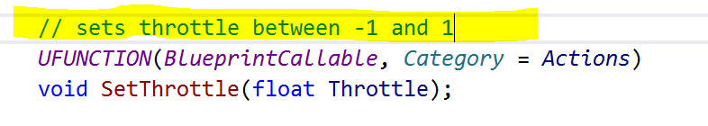

In Unreal:

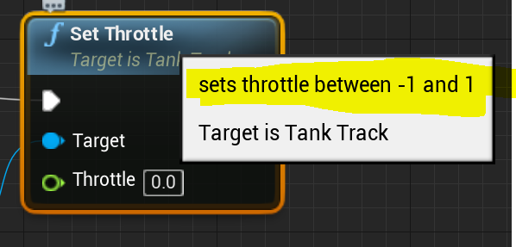

#### Creating in Unreal

Simply go to add new > c++ class. Note you can set to public or private, defaults public. Puts in different folders based off selection.

* Public puts header in public and cpp in private
* Private puts both in private folder.
* Both folders are subfolders of source folder

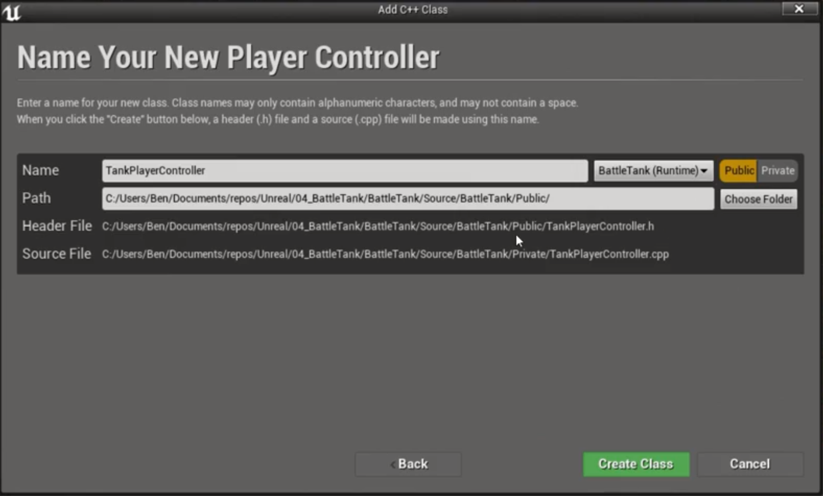

### Class system / Viewer

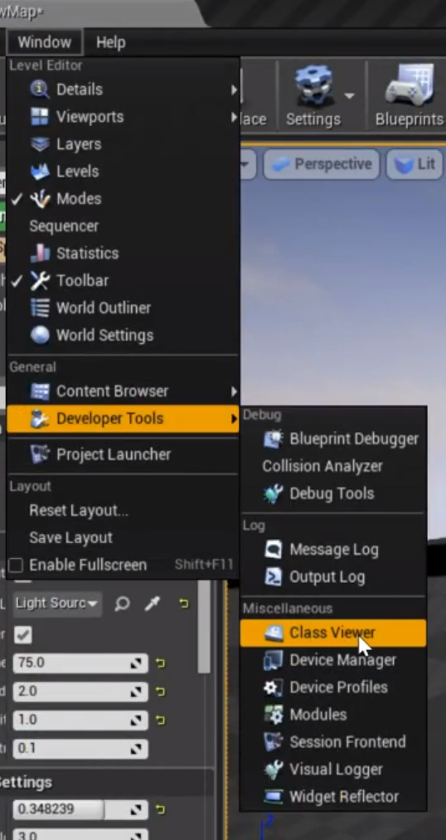

* Class Viewer is useful for determining types too. For example, you can type pawn in the search field, and will see it’s a child of actor, so know its an AActor.

### Trigger Volumes

Invisible Volume in game world that can tell code to do something.

### Player

### Pawn

* Is of type APawn which is AActor
* You can’t assign pawn to anything in editor, but can hit play, eject and then assign. Note this is not persistent.
* Game Mode specifies default pawn class
* If you make your own pawn (blueprints), you can change things like:
  + Eye height
  + Add physics so you have gravity. When jump fall back down. – just turn on simulate physics on the Collision Component in the blue print. Similarly can turn on collision – generate **overlap events** (so collision knows about you) and generate hit events
  + Note if the actor moves on its own you can constrain x,y,z   
    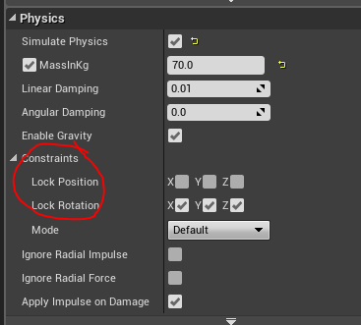

#### Controlling

You can do just blueprints, or make a C++ class that inherits player controller and make blueprint inherit C++ class. You can extend functionality in this class. See reparent to a different C++ Class if you need to reparent an existing blueprint.

### AI

#### Controlling

Can create a C++ class. Set this in the blueprint for the pawn. Set under Pawn in the details tab.

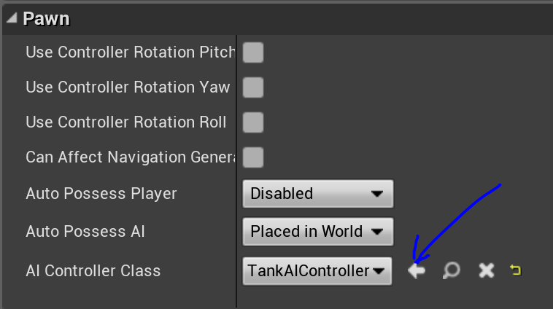

The AI gets control of a pawn by saying auto-possess.

### Actor

#### Getting Locations

* GetOwner() – get owner of this actor, returns actor that owns.
* GetWorld() – returns a world pointer
* GetFirstPlayerController – gets first player, to get pawn GetFirstPlayerController()->GetPawn()

### Spawning

Can use SpawnActor:



* Put the class type in <>
* The first argument gives the instance, then location and rotation

#### Moving

Use a ProjectileMovementComponent

### 2D to 3D projection of a point

Useful for aiming. Two ways, Note that neither accesses the location of the cross hair from the blueprint widget ui. Hard coded. Would be better to access from the ui.:

1. Use GetHitResultAtScreenPosition  
   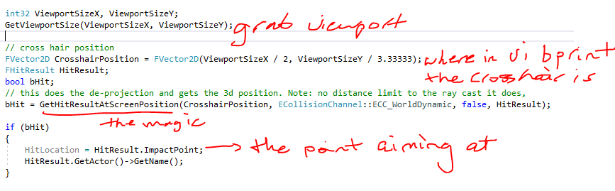
2. Use DeProjection of a 2d viewport location to a 3d point
   1. Deprojection to get look direction. Note that crosshairXlocation and location are vars, where as above coded into calculation.  
      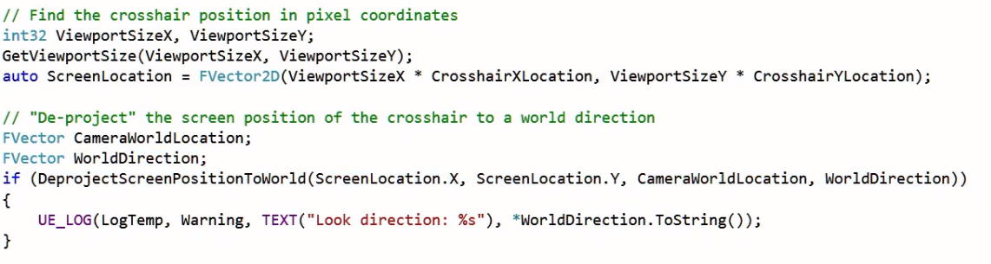
   2. Line trace – note this would go above where the UE_LOG is. Also worlddirection is lookdirection. Also HitLocation should be assigned to HitResult.Location :

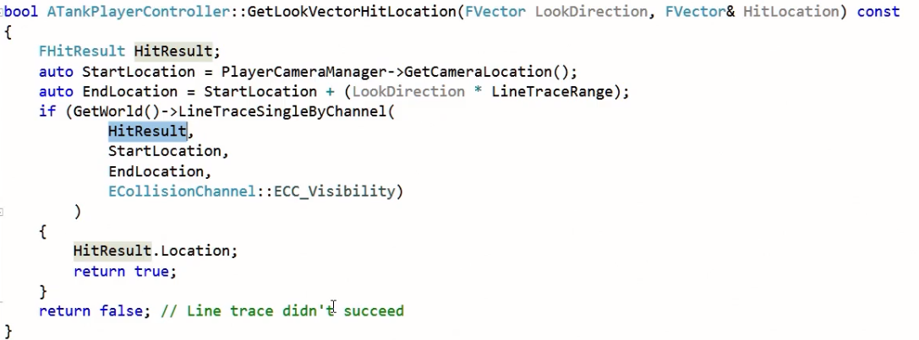

### Transforms

* GetActorLocation() returns the same as the Transform.GetLocation()
* If you attach an object to another via C++ and don’t see all transforms – just scale, then means its not attached. Before you think its code, try restarting unreal and see if fixed. If not clear derived files.

### Runtime Feedback

#### UE_LOG

* Use UE_LOG – a macro - to print to the Output Console
* **WARNING:** These are macros, so hard to debug, visual studio errors almost useless.
* Visit for info <https://wiki.unrealengine.com/Logs,_Printing_Messages_To_Yourself_During_Runtime>
* UE_LOG(log, verbosity level, TEXT(“text here”));
* To see the output, Open Windows->Developer Tools->Output Log
* Note that if passing a string variable to TEXT, then it expects *FString, so add a * to dereference. Example:   
   FString ObjectName = GetOwner()->GetName();

UE_LOG(LogTemp, Warning, TEXT("Position Report for %s", *ObjectName));

* A further note about strings. If you do UE_LOG(LogTemp, Warning, TEXT(*HitLocation.ToString())); will fail. It will complain expecting a TCHAR pointer and say too many parameters. Solution is to add a formatter: UE_LOG(LogTemp, Warning, TEXT(“%s”),HitLocation.ToString());

### Events / Ticking

Tick events run every frame. Can optimize classes that don’t tick with bCanEverTick property set to false

* There is the main tick :   
  Tick(float DeltaTime) for actors
* There is an actor component tick as well:   
  TickComponent(float DeltaTime, enum ELevelTick TickType, FActorComponentTickFunction *ThisTickFunction)

#### OnHit / Collision Events

##### Components

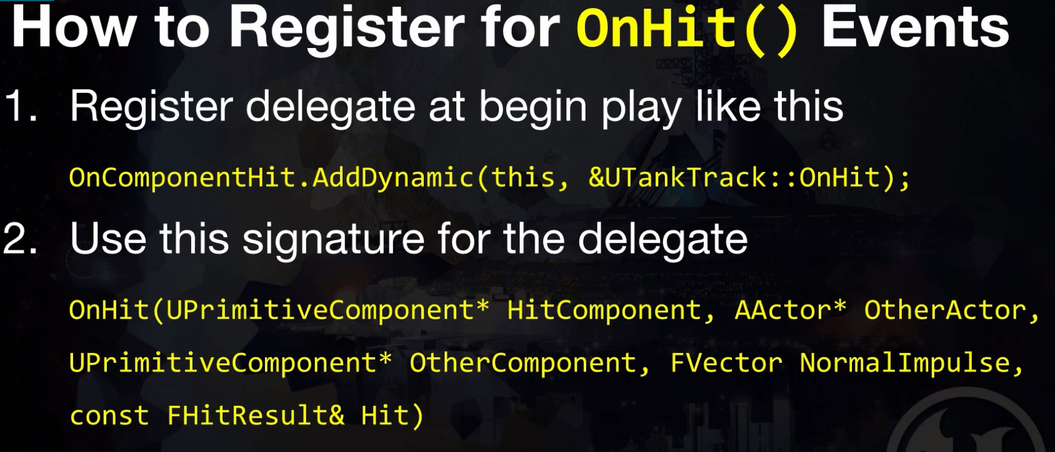

**BE SURE OnHit is private!**

### Variables / Properties / Attributes

* Any variable in C++ that doesn’t use the UPROPERTY Macro must have its memory managed by you. I.E. you do the garbage collection.

#### UPROPERTY

FORMAT:  
UPROPERTY(arguements)  
varType varName

A macro that informs the engine the variable exists for the purposes of garbage collection, and the statements inside the macro tell Blueprints and the editor how to interact with the variable.

* The only reason not to use the UProperty macro is if the variable type isn't exposed to Blueprint.
* EditDefaultOnly is the default class, doesn’t apply to instances you create in the world
* EditInstanceOnly applies just to instances
* EditAnywhere applies to instances and default
* The VisibleAnywhere, VisibleDefault, VisibleInstance are same as above, just can’t edit/write
* BlueprintReadOnly and BlueprintReadWrite available
* Category = ”” – puts variable under a group in detail panel with name in parenthesis
* meta = () adds metadata
* Can combine multiple specifiers

### Polling and Events

* If don’t need to tick, then disable for performance by setting PrimaryComponentTick.bCanEverTick = false; in constructor

### TArray

Unreal’s go to container class.

### Pointer Protection

* Unreal will crash if try to follow a nullptr
* Best practices:
  + Always initialize pointers to nullptr
  + Check pointers before use for nullptr:

if (!PointerVariable) { return; }

* ensure keyword even better – use assertions. Gives better error reporting:

if (!ensure(PointerVariable)) { return; }

### Vectors

#### Unit Vector

Use GetSafeNormal(); which is a member of FVector

#### Forward Vector

The X direction only, GetForwardVector();

#### Getting rotation from a vector

Call member function rotation(), for example Barrel->GetForwardVector().Rotation();

### Audio

#### Blueprints

##### Sound Effects with an Animation at their location

* Use a play sound at location node
* Add an event track to the timeline node
* Drag the Sound Timing pin on the timeline node to the event tick on the sound node.  
  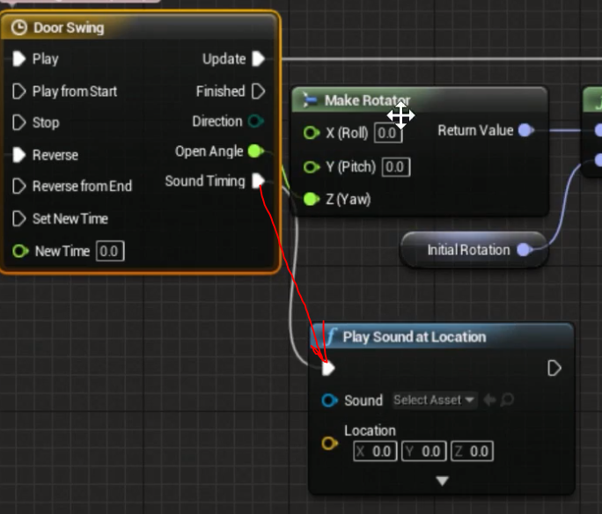
* Plug an actor get rotation into the sound node location pin

### BluePrints

How C++ and Blueprints work together

#### Reparent to a different C++ Class

* In Blueprint, click Class settings, can then change parent class at top. Class must be compiled to show up.

#### Class Settings

* Can reparent
* Can toggle on or off construction updating – calling constructor. Either will do every frame or only when drag and release. Optimization for heavy objects.

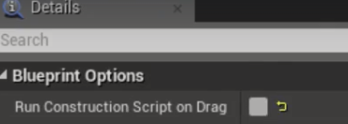

#### Event Based Blueprints

Have blueprint fire an event based off something. Use BluePrintImplementableEvent. Example:

UFUNCTION(BlueprintImplementableEvent, Category = "Setup")

void FoundAimingComponent(UTankAimingComponent* AimCompRef);

* Doesn’t require implementation in c++, just declaration

#### Exposing Events

* Multicast Delegates only work on actors
* First in C++ header need to add outside the class this: DECLARE_DYNAMIC_MULTICAST_DELEGATE(FOnOpenRequest);
  + Creates a new class type FOnOpenRequest
* Next in C++ header, add to the class (make public):

UPROPERTY(BlueprintAssignable)

FOnOpenRequest OnOpenrequest;

* Now in the .cpp file, in a class method you can broadcast to blueprints: OnOpenrequest.Broadcast();
* In blueprints need to select the component you are referencing. For example, the above is from the OpenDoor c++ component, so in blueprints:  
  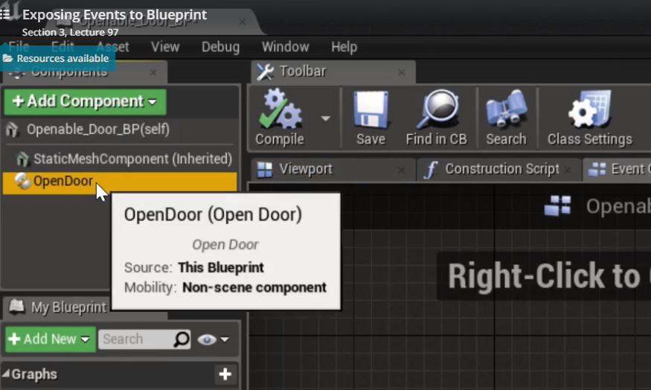
* Next, search for a node named after the instance of the delegate you created, in the above case OnOpenRequest:  
  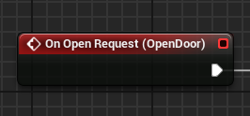

#### Exposing Functions

* Above a function (must be public)  
  UFUNCTION(BlueprintCallable, Category = Setup)
* Then in blueprints can create a node that is the function:

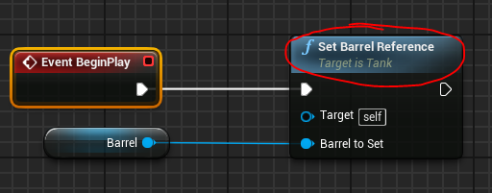

#### Exposing Variables

* Allow Blueprint to access variables made in C++
* Just add UProperty with appropriate blureprint keyword, for example (NOTE this is read only (blueprints can read not write to), but could be BlueprintReadWrite too if that was desired):



* Allows you to drag into blueprints. For example can drag TankMovingComponent in since it has the uproperty, but can’t drag Aiming Component since it doesn’t have a UProperty in the C++ class

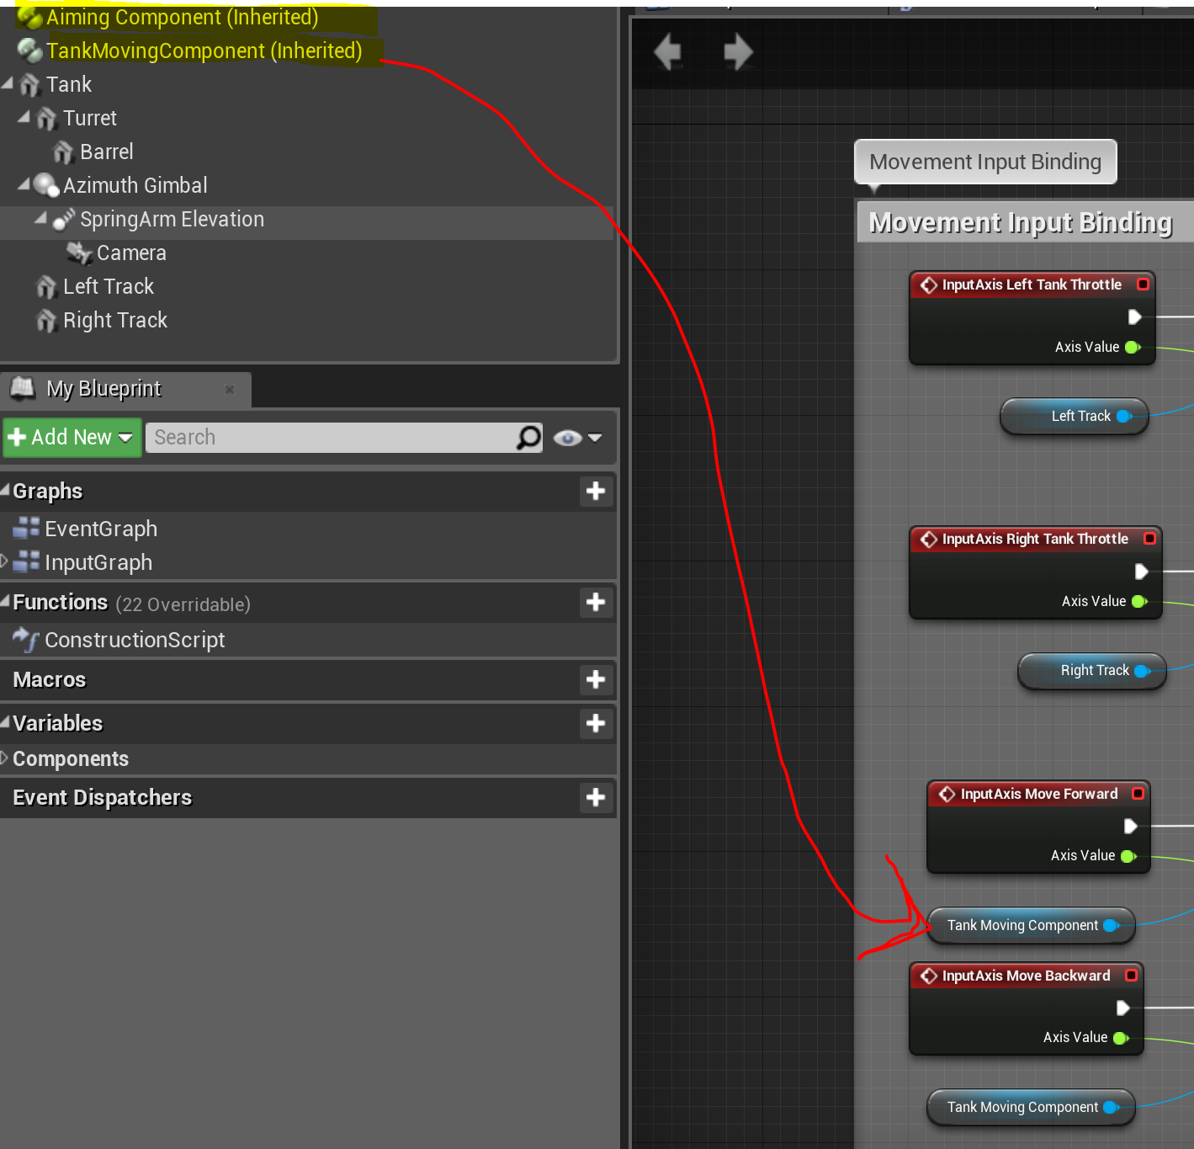

#### Adding Components Via C++ Constructor

* Create your component class.
* Then in the c++ class for that will use the component, create a pointer for the component.
* In the class c++ constructor that uses the component, create a subobject assigned to the above pointer.
* Example. I have a blueprint Tank_BP, that has a c++ Tank class as parent (it inherits pawn). I create an actor component class called TankAimingComponent. In the Tank class, I create a pointer to this aiming class. Then in the Tank constructor, use this code to place the aiming class as a component in the Tank_BP:

TankAimingComponent = CreateDefaultSubobject<UTankAimingComponent>(FName("Aiming Component"));

The aiming class goes in the <> and the FName is what will show in the BP.I.e:  
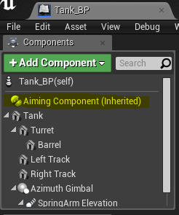

##### Controlling Parenting

* You can set as root with: SetRootComponent(CollisionMesh);
* You can set as child with: LaunchBlast->SetupAttachment(CollisionMesh);  
  In this case the LaunchBlast becomes a child of CollisionMesh. You could also use AttachToComponent(RootComponent, FAttachmentTransformRules::KeepRelativeTransform);, but Unreal recommends SetupAttachment for non registered components

#### Exposing Blueprint

To allow a blueprint to use another blueprint, say a tank blueprint use a projectile blueprint, do the following. Using tank/projectile example to illustrate:

1. create a c++ class, then a blueprint from the class for the projectile.
2. In the tank class add a Uproperty that is a Tsubclassof. Note better to use TSubClassof since a Uclass lets you choose anything, tsubclassof limits to this class. Also it makes a pointer even though doesn’t look like it. Ex:  
   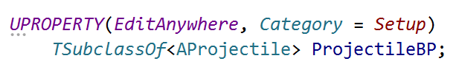
3. In the tank blueprint, should see a property in details window called ProjectileBP where can pick the blueprint.

#### Properties

* Can create properties that show up in details window with UPROPERTY. To put in a custom category use Category=””
* Can hide categories for custom classes using the hidecategories keyword in the class. For example this would hide collisions group/category in the details window in blueprints:  
  

#### Variables

When drag out from a node can say promote to variable in the menu that pops up

#### Enums

Can use enums defined in C++. Just expose as a uproperty. In this example, getting the class via the BP Aiming Component Reference, then getting the enum var, then use a select to do things based off enum states. This sets color of the aim point UI image.

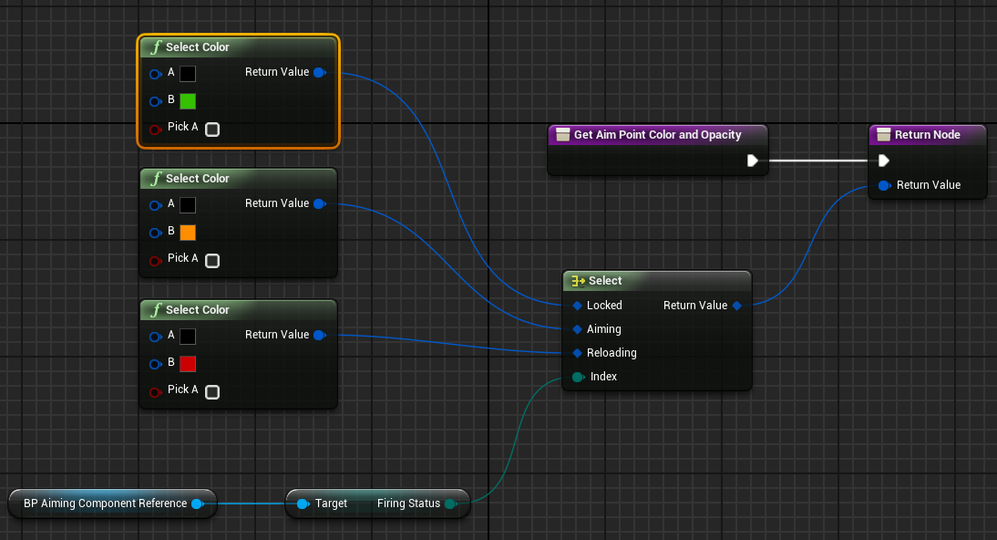

#### Debugging

When you hit play in the unreal editor, and have the blueprint graph open, you can see what is happening. Notice the execution flow indicated by the orange line:

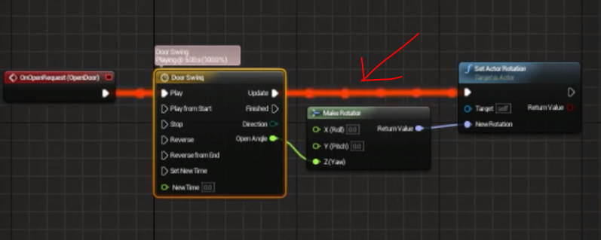

## Directory Structure

For more information look at docs: <http://docs.unrealengine.com/latest/INT/Engine/Basics/DirectoryStructure>  
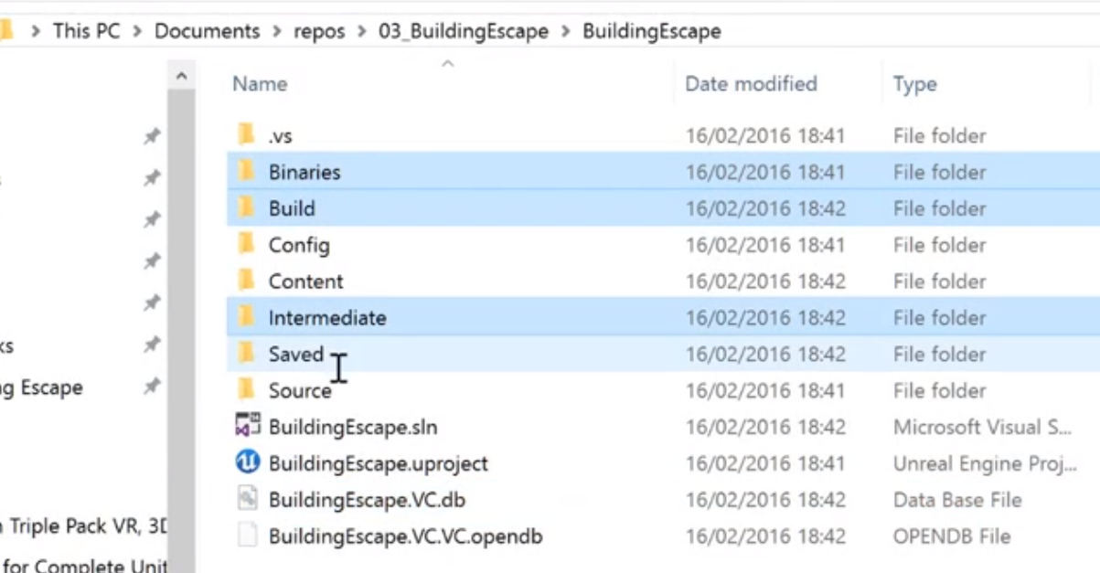

### Derived Files

* Speed up unreal load times/etc.. and can easily be rebuilt, opposed to code assets level layout etc which can’t be
* Don’t version control these
* Binaries, Build, DerivedDataCache, Intermediate, and Saved are derived folders
* .VC.db (BuildingEscape.VC.db in the image above) is a derived file

## Debugging

### Visualization

#### DrawDebugHelpers

Has helper functions to help see what is happening like DrawDebugLine. #include "DrawDebugHelpers.h"

### Compiling

Sometimes compiling in Unreal instead of Visual Studio can give more helpful errors

### Checking Ticks

Easy way is to use time:  
 auto Time = GetWorld()->GetTimeSeconds();

UE_LOG(LogTemp,Warning,TEXT("%f"), Time)

### Visual Studio Debugger

1. First Debug>Attach to process  
   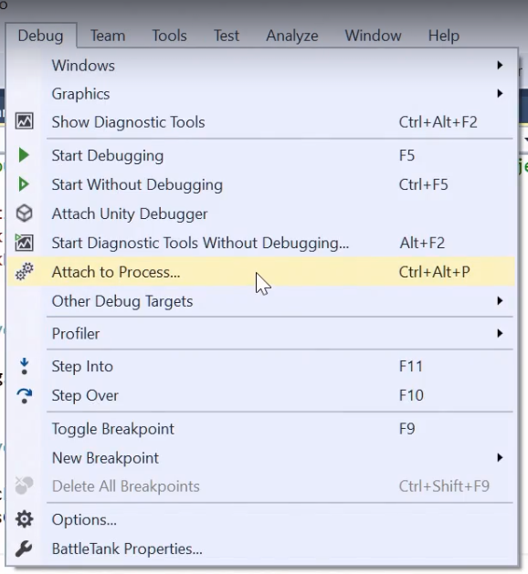
2. Find Unreal – must be running  
   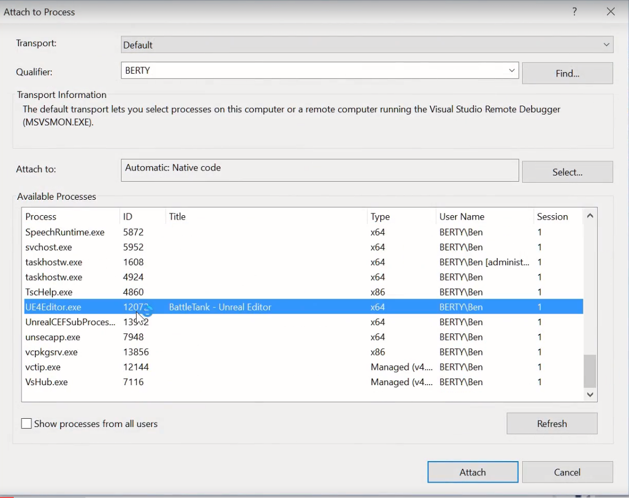
3. Now hit Play in Unreal. Visual Studio will intercept and exceptions / crashes.
   1. Hitting Break will stop Unreal execution right before crashes. Can’t access it, but Visual Studio will have useful debugging info. Will also have yellow arrow pointing at line to be executed  
      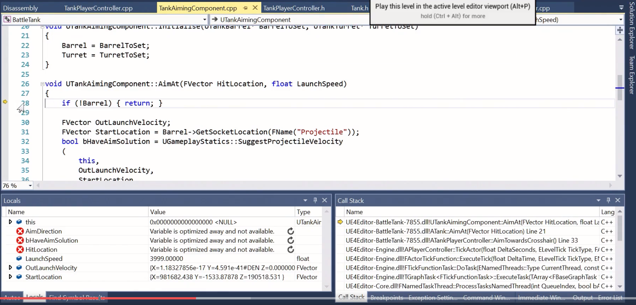

### Refactor Issues

Often when you change code, blueprints lose values you set. For example: Refactoring AI controller for tanks caused the tank blueprint to lose the AI Controller Class. A good thing to always check is that Unreal didn’t lose a setting!

### Unreal Issues

Some easy things to try:

* RE-create!
  + If it’s an object in world, try removing and bringing a new one in
  + In blueprints try re-creating the node.
  + In Blueprints try refreshing the node
* Close Unreal and restart
* Close Unreal, remove derived folders/files, and rebuild project
* If you change an Enum in C++, have to restart Unreal to see change.
* Linker errors are usually from mismatches between header file and cpp file

# VISUAL STUDIO

## Projects and Solutions

* Solution / Section is a group of projects, the images below show the relationship to folder structure. Solution is the parent, Name (i.e. project name) is the child.  
  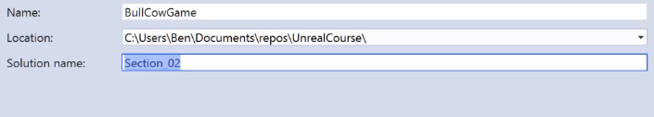 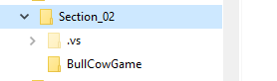
* Best to add files via Solution Explorer by right clicking on Project.  
  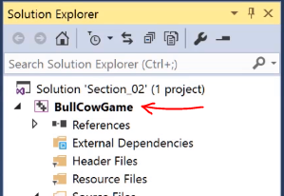

## Tools

### Extraction

Should be able to right click on code and get quick action which opens extraction. If not go to Tools at top of menu bar, then options. Go to Text Editor->C/C++->Experimental and set Enable Extract Function to true under refactoring.

* Note: automatically creates a header file.

## Debugging

### BreakPoints

* Add a breakpoint by clicking in grey margin.   
  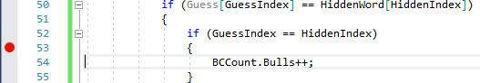
* Then hit F5 or Debug->Start Debugging. Use the continue button to keep stepping through breakpoints.  
  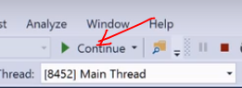

## Watch

* While in debugging mode, right click on a line and Add Watch  
  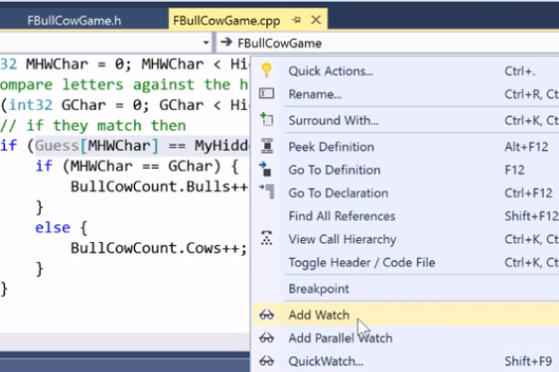

## Management

### Task List

* Under View->Task List
* Can use TODO in comments to add items to task list.
* Can use other tokens too, define in options.

## Shortcuts

* Ctrl+r followed by ctrl+r : Rename everywhere
* Ctrl+h – quick replace
* Ctrl+k then c to comment out a selection

## Troubleshooting

* Be sure to rebuild after change in a .h or .cpp if not getting correct result

# GAME DEVELOPMENT

## Game Design Document

* The problem emotionally the game solves
* Chooses Concept, Rules, Requirements, Architecture
  + For example, Bulls and Cows Game Concepts and Rules  
    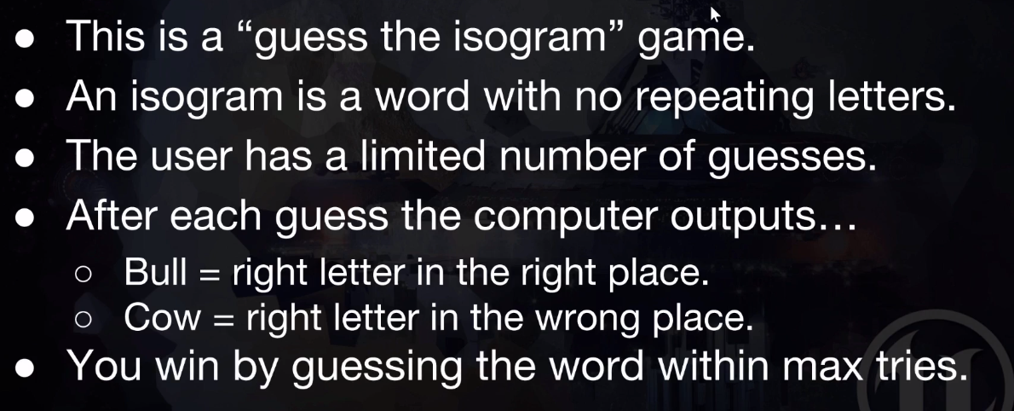
* Requirements
  + Inputs, Outputs, Tasks User asked, Performance Limits, Assets (art, sound, story text)
  + These can translate into code
  + Include a Future Ideas List

## TO DOCUMENT

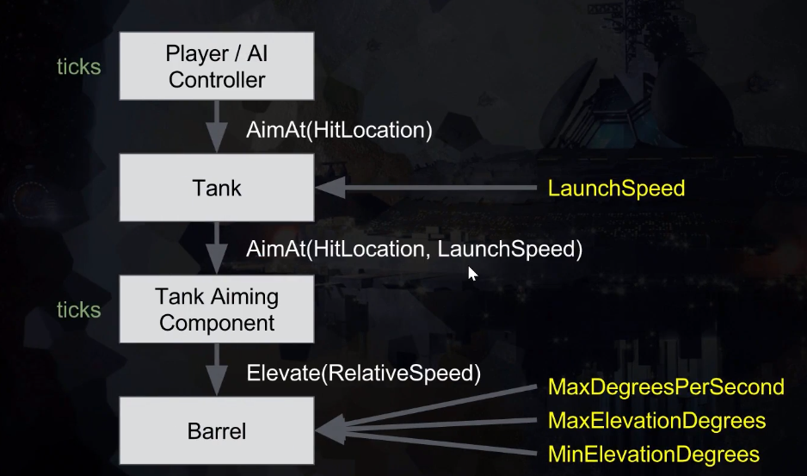

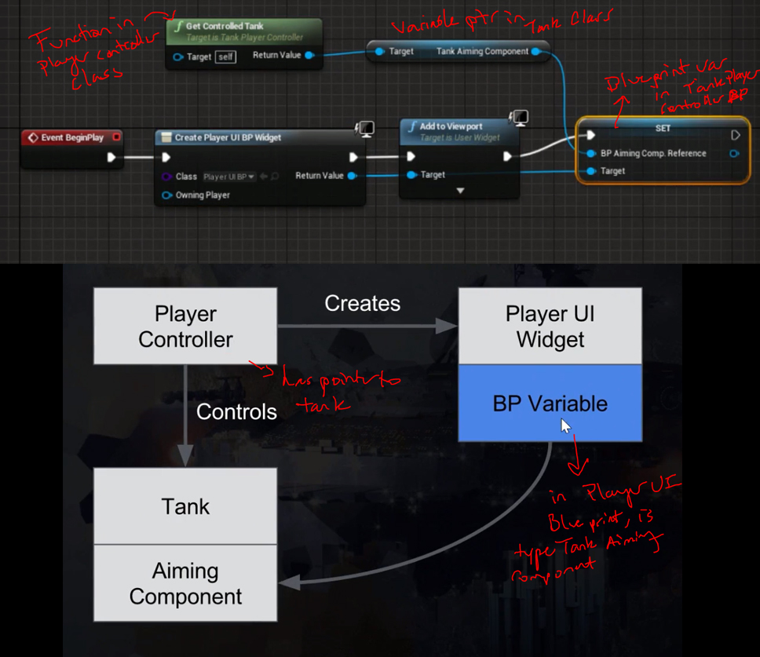

### Getting Projectile Landing Location

Use SuggestProjectileVelocity which returns a bool and sets the direction vector:

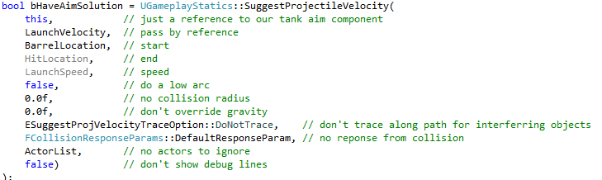

**WARNING:**

must include all parameters up to ESuggestProjVelocity…, otherwise will break (will produce inconsistent results) -- bug in code. Issue is it shows everything after launch speed as optional, but that will break it if you don’t include.

## Grabbing System

* Modify Default Pawn Actor
* InheritBlueprint
* Create Grabber Logic
  + Ray Casting

### Modifying Default Pawn Actor

* In unreal’s editor, make a blue print class by selecting default pawn (need to hit play), and going to Blueprints->Convert Selected Actor to Blueprint Class
* Add a new C++ component to Blueprint, this will be the grabber. NOTE: create in the details tab, once created go back into blueprint editor and add the Grabber component.
* Add a physicsHandle component as well in the blueprint

### Inherit Game Mode Blueprint

* In content browser select the game mode c++ class (assumes started unreal as a c++ project). Right click to create blueprint from class.
* Set the game mode in project settings to this blueprint game mode
* Also in blueprint set the default pawn to the default pawn created above in (1)

### Create Grabber logic

#### Get Player Location

* In your grabber h file, add a reach variable
* In the cpp file, get the player viewpoint location and rotation sample code. Notice its taking in references and modifying in function without returning:  
  // Get the player viewpoint this tick

FVector PlayerViewLocation;

FRotator PlayerViewRotation;

GetWorld()->GetFirstPlayerController()->GetPlayerViewPoint(

PlayerViewLocation,

PlayerViewRotation

); // note that its modifying these in function, its taking the reference

* The rotation vector is a unit vector, so need the reach multiplier. Here’s an image showing the concept:  
  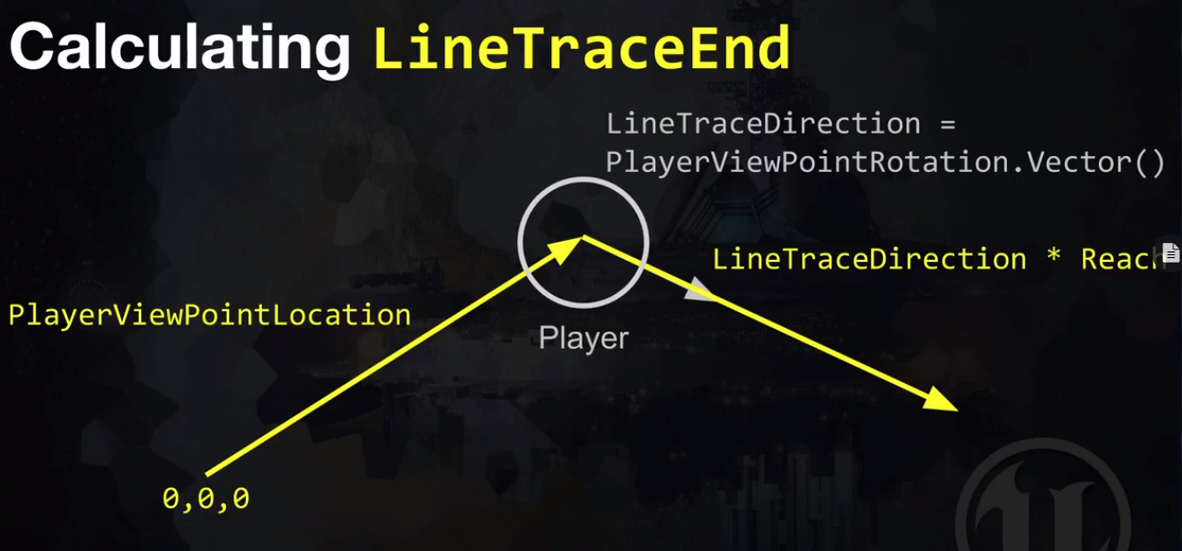

#### Ray-Cast / Line Trace

* + In cpp file after get end point of line, send ray:  
    /// Setup query parameters - pass empty string for tag, false for not using complex collisions, this pawn / self for actor to ignore

FCollisionQueryParams TraceParams(FName(TEXT("")), false, GetOwner());

/// Line-trace (ray cast) out to reach distance

FHitResult Hit;

GetWorld()->LineTraceSingleByObjectType(

Hit,

PlayerViewLocation,

LineTraced,

FCollisionObjectQueryParams(ECollisionChannel::ECC_PhysicsBody),

TraceParams

);

/// See what we hit

AActor* ActorHit = Hit.GetActor();

if (ActorHit) // make sure valid, if no hit then this is nullptr

{

// grab object

}

* + To make things clearer, you can convert collision channels to object type.
    - Include Engine/EngineTypes.h

TArray<TEnumAsByte<EObjectTypeQuery>> TraceObjectTypes;

TraceObjectTypes.Add(UEngineTypes::ConvertToObjectType(ECollisionChannel::ECC_WorldStatic));

World->LineTraceSingleByObjectType(Hit, StartPos, EndPos, TraceObjectTypes)

#### Physics Handler

* + Get the handle created above in the default pawn blue print in the grabber begin play function doing:  
    PhysicsHandle = GetOwner()->FindComponentByClass<UPhysicsHandleComponent>();

#### Input Component

* + Get the input component which appears at run time  
    InputComponent = GetOwner()->FindComponentByClass<UInputComponent>();
  + Create a binding in Project Settings > Engine > Input:  
    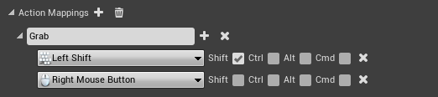
  + Bind the action to a method. Create the function Grab in the class.  
    InputComponent->BindAction("Grab", IE_Pressed, this, &UGrabber::Grab);
  + Can also create a release method like the grab one, i.e.:  
    InputComponent->BindAction("Grab", IE_Released, this, &UGrabber::Release);

#### Grabbing Object and Releasing

* In the grab method, which is called when key pressed, usethe hit object from ray casting, and create a UPrimtiveComponent pointer. Then use the physics handle to attach an object. Example code:  
  /// Try to reach any actors with physics body collision channel set

auto HitResult = GetFirstPhysicsBodyInReach();

UPrimitiveComponent* ComponentToGrab = HitResult.GetComponent();

auto ActorHit = HitResult.GetActor();

if (ActorHit)

{

/// If we hit something then attach a physics handle, if use GrabComponentAtLocation then object rotation will simulate and fly around

PhysicsHandle->GrabComponentAtLocationWithRotation(

ComponentToGrab, //ComponentToGrab

NAME_None, //grab what bone name, if any

ComponentToGrab->GetOwner()->GetActorLocation(), //grab location

ComponentToGrab->GetOwner()->GetActorRotation() //grab rotation

);

}

* In the tick event method, need to move the grabbed object with pawn, set it to the line trace end:

// if physics handle attached

if (PhysicsHandle)

{

if (PhysicsHandle->GrabbedComponent)

{

// move the object we are holding

PhysicsHandle->SetTargetLocation(LineTraced);

}

}

* To release, PhysicsHandle->ReleaseComponent();

### Setup Collisions

* In Unreal choose collision objects. For this example, setting a chair and table to physicsActor collision by clicking Simulate Physics in details tab under Physics - this sets both the collision preset and makes the object moveable. This makes it easy to tag other objects to be used in grabber. Note using an Object Trace method.

## Health Bar System

Use blueprints and C++ to display health bar over player. Will use tank example

* In Tank class, create a pureblueprint function that pulls the health.  
  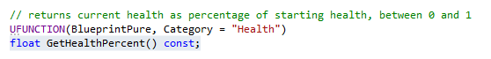
* Then create a widget blueprint for the health bar. Drag a progress bar into the canvas. Set its anchor to the whole screen and set the bar to fill the screen by setting offsets to 0:  
  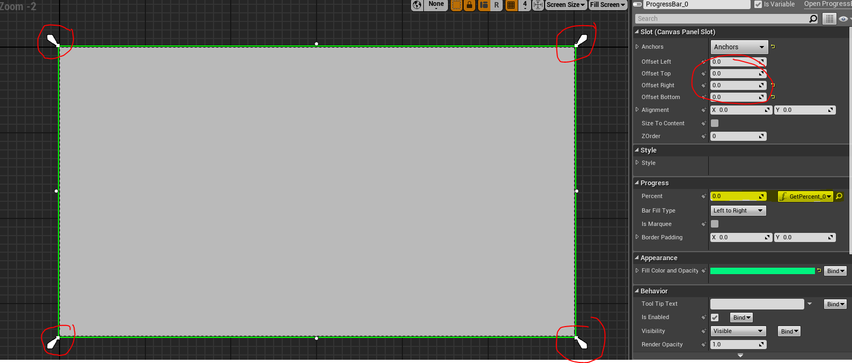
* Notice the yellow highlight above. That is the percent and you click bind to let it create a function. Then in the function we create a variable of type tank, drag it into graph, and from the My Tank node drag off to get the blueprint pure function from above:  
  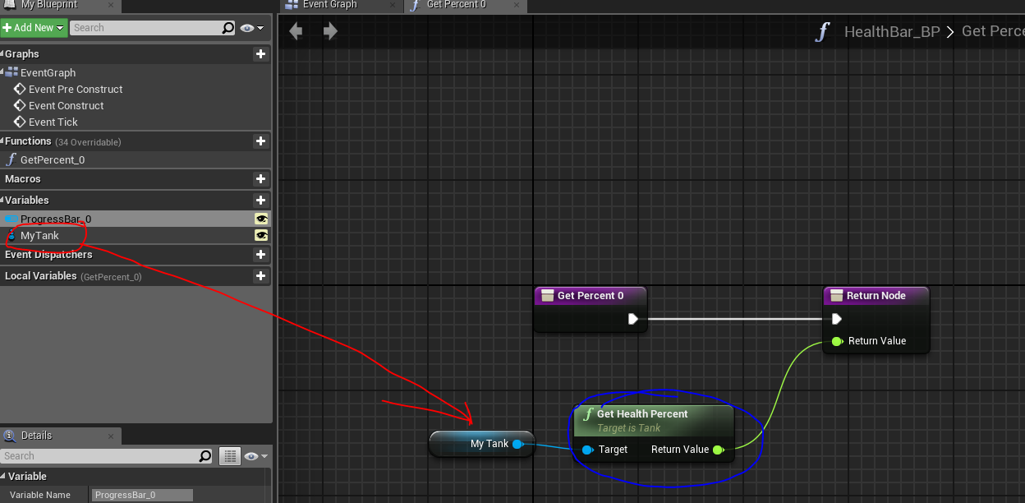
* Now in the Tank blueprint, Create a widget component by clicking add component and searching widget:  
  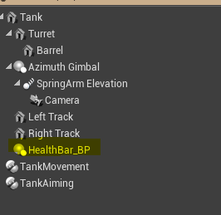
* Drag the widget component created into the graph. Then use a get user widget node. Cast that to the healthbar blueprint. Finally drag a set node to set the Tank variable in the health bar blueprint to this tank instance. Don’t forget to add a self node to My Tank, just type ‘self’

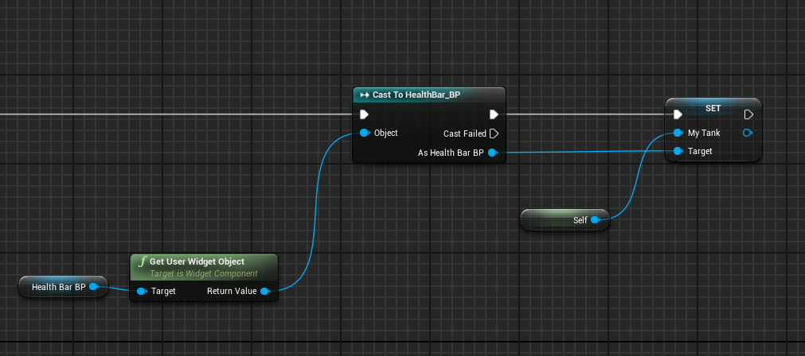

## Observer Game Pattern – Event Based Notifications

The basic idea is we have some code, and it doesn’t care who knows or listens, but sends a notification that something happened. Some other separate code subscribes and listens for the event and acts on it. For example an achievement system. You could put each achievement code in every aspect of the code, but this is messy. We want all code concerned with something to be in one place. With achievements, a wide range of different behaviors trigger it. Don’t want to couple achievement code to every aspect of gameplay code. Consider a fell off bridge achievement. The physics engine sends a notification that someone fell off a bridge. The achievement system subscribes to that notification.

### How it Works

#### The Observer

Defined by this interface:

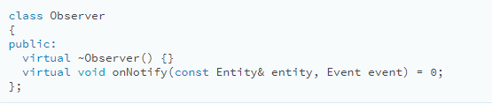

Any class that implements this becomes an observer:

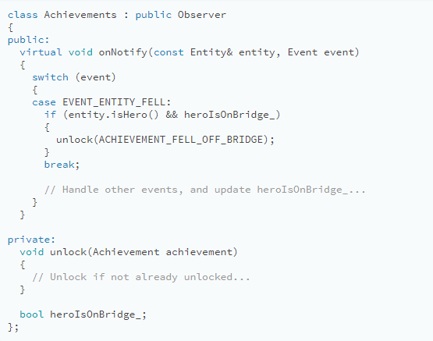

#### The Subject

The notification method is invoked by the object being observed. It has two jobs.

1. It holds the list of observers (**Note:** that you would really want the array to be dynamic):

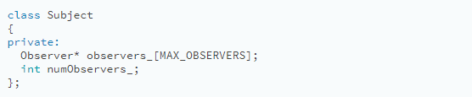

The subject also needs a public API for modifying list:

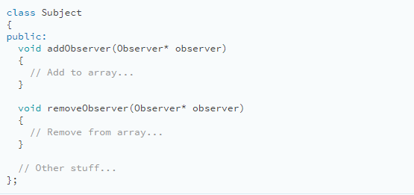

A few Notes:

* A public API allows outside code to control who receives notifications. The subject communicates with the observers, but it isn’t coupled to them. In our example, no line of physics code will mention achievements. Yet, it can still talk to the achievements system. That’s the clever part about this pattern.
* It’s also important that the subject has a list of observers instead of a single one. It makes sure that observers aren’t implicitly coupled to each other. For example, say the audio engine also observes the fall event so that it can play an appropriate sound. If the subject only supported one observer, when the audio engine registered itself, that would un-register the achievements system.

1. The other job of the subject is sending notifications:

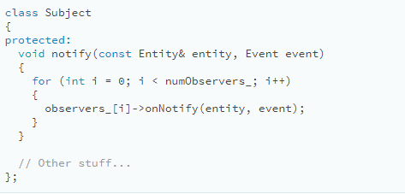

Then:

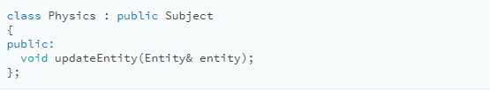

A few Notes:

* updateEntity lets us make notify() in Subject protected. That way the derived physics engine class can call it to send notifications, but code outside of it cannot. Meanwhile, addObserver() and removeObserver() are public, so anything that can get to the physics system can observe it.
* In real code, avoid using inheritance here. Instead, I’d make Physics have an instance of Subject. Instead of observing the physics engine itself, the subject would be a separate “falling event” object. Observers could register themselves using something like:

physics.entityFell().addObserver(this);

* This is the difference between “observer” systems and “event” systems. With the former, you observe the thing that did something interesting. With the latter, you observe an object that represents the interesting thing that happened.
* When the physics engine does something noteworthy, it calls notify() like in the motivating example before. That walks the observer list and gives them all the heads up.

# CODE REFERENCE

## Hashing

### Find first repeating character

// CPP program to find the first

// repeated character in a string

#include <bits/stdc++.h>

using namespace std;

// Returns first repeating character in str.

char firstRepeating(string &str)

{

    // Creates an empty hashset

    unordered_set<char> h;

    // Traverse the input array from left to right

    for (int i=0; i<str.length(); i++)

    {

        char c = str[i];

        // If element is already in hash set, update x

        // and then break

        if (h.find(c) != h.end())

            return c;

        else // Else add element to hash set

            h.insert(c);

    }

    // If there was no repeated character

    return '\0';

}

// Driver method to test above method

int main ()

{

    string str = "geeksforgeeks";

    cout << firstRepeating(str);

    return 0;

}